R166 Composite Pressure Armour
Qualification Plan

Project Ref. | R166
Document No. | R166Exxx
Revision | 0
Date | 10 February 2017
Author | James Latto
Prepared For | DNV
GE Document Classification and Security * | GE Confidential

* Public – Non-sensitive, published/public domain information, GE Internal – Company information not for disclosure to the public or to external parties but generally available to all employees and authorised non-employees, GE Confidential – Information that is sensitive or confidential within the Company and intended for business use only by those with a need-to-know, GE Restricted – Information that is extremely sensitive or private, of highest value to the Company, and intended for use by named individuals only

R166 Composite Pressure Armour
Document No | R166Exxx |  |  | Rev |  | 0 |  | Project |  | R166
Document Classification and Security |  |  |  |  | GE Confidential
Enter abstract/brief summary of document.

Keywords
Date | Rev |  | Originated |  |  |  | Reviewed |  | Approved
14/09/2012 | 00 |  | James Latto |  |  |  | Vineet Jha |  | Neville Dodds
Click here to enter a date. | 01
Rev | Description
00 | Draft issued for review
01 | Initial issue
02
Internal Distribution |  | Wellstream Library
External Distribution |  | DNV
* Public – Non-sensitive, published/public domain information, GE Internal – Company information not for disclosure to the public or to external parties but generally available to all employees and authorised non-employees, GE Confidential – Information that is sensitive or confidential within the Company and intended for business use only by those with a need-to-know, GE Restricted – Information that is extremely sensitive or private, of highest value to the Company, and intended for use by named individuals only

R166 Composite Pressure Armour

Table of Contents
1 Introduction 1
1.1 Summary 1
1.2 Problem Statement 2
1.3 Background and Existing Technologies/Methodologies 2
1.4 Proposed Hybrid Design Approach 3
1.5 Main Functional Layers 4
1.5.1 Carcass 4
1.5.2 Barrier 4
1.5.3 Composite Pressure Armor 5
1.5.4 Metallic Tensile Armor Layer (T1 and T2) 6
1.5.5 Additional Layers 6
1.5.6 End Fitting - Background 7
1.5.7 Manufacturing Process 9
2 Project Approach and Execution 10
2.1 Project Approach 10
2.2 Development streams 11
2.3 Development cycle 12
2.4 Project Execution 14
2.4.1 FMECA 14
2.4.2 Stream 1 – Pipe Design and Proof of Concept 15
2.4.3 Stream 2 – Manufacturing Development 16
2.4.4 Stream 3 – Supply Chain Development 18
2.4.5 Stream 4 – Pipe Qualification and Full-scale Validation 19
3 Statement of work 21
3.1 Project Management and Administration 21
3.1.1 Task 1: Program Management Plan & FMECA 21
3.1.2 Task 2: Technology Status Assessment 21
3.1.3 Task 3: Technology Transfer Plan 22
3.1.4 Task 4: Other Reports and Special Items 22
3.2 Phase 1 - Product Development 22
3.2.1 Task 5: Pipe Structure Development & Analysis 22
3.2.2 Task 6: Material Development & Categorisation 23
3.2.3 Task 7: Prototype Pipe Production 23
3.2.4 Task 8: Quality Control & NDE Development 24
3.2.5 Task 9: Mid-Scale Prototype Testing & Validation 24
3.2.6 Task 10: Design and analytical tool development 24
3.2.7 Task 11: Phase 1 Design Review 25
3.3 Phase 2 – Manufacturing & Prototype Assessment 25
3.3.1 Task 12: Project Management and Administration Update 25
3.3.2 Task 13: Pipe Structure Development & Analysis 26
3.3.3 Task 14: Prototype Pipe Production – Module 1 26
3.3.4 Task 15: Material Categorisation 27
3.3.5 Task 16: Quality Control & NDE Optimisation 27
3.3.6 Task 17: Mid-Scale Prototype Testing & Validation 28
3.3.7 Task 18: Design and analytical tool updates 28
3.3.8 Task 19: Phase 2 Design Review 28
3.4 Phase 3 – Qualification pipe production & initial qualification assessment 29
3.4.1 Task 20: Project Management and Administration Update 29
3.4.2 Task 21: Pipe Structure Development & Analysis 30
3.4.3 Task 22: Qualification Pipe Production 30
3.4.4 Task 23: Material Categorisation & Specification 31
3.4.5 Task 24: Mid-Scale Prototype Testing & Validation 31
3.4.6 Task 25: Design and analytical tool updates 31
3.4.7 Task 26: – Future Development & Continuous Improvement 32
3.4.8 Task 27: Phase 3 Design Review 32
3.4.9 Task 28: Phase 3 Business Review 32
3.5 Qualification Phase – Full-scale pipe qualification & verification 33
3.5.1 Task 29: Small-scale material categorisation for qualification 33
3.5.2 Task 30: Mid-scale qualification & validation testing 33
3.5.3 Task 31: Full-scale qualification & validation testing 34
3.5.4 Task 32: Qualification Report & IVA Approval 34
3.5.5 Task 33: Approval to quote, Product Validation Review & NPI Toll Gate Reviews 34
3.5.6 Task 34: Review & Close 35
4 Project Execution Plan 36
4.1 FMECA Summary 1
4.2 Project Timeline & Work Breakdown Structure 1
4.3 R166.B.5.C Engineering 3
4.3.1 R166.B.5.C.1 Specifications 3
4.3.2 R166.B.5.C.2 Pipe Design 4
4.3.3 R166.B.5.C.3 End Fitting Design 5
4.3.4 R166.B.5.C.4 Design and Analytical Tools 5
4.3.5 R166.B.5.C.5 Small-scale Testing 8
4.3.6 R166.B.5.C.6 Mid-scale Testing 11
4.3.7 R166.B.5.C.7 Full-scale Testing 13
4.3.8 R166.B.5.C.8 Pipes and Samples 15
4.3.9 R166.B.5.C.9 DNV New Technology Qualification 16
4.4 R166.B.5.D Manufacturing 16
4.4.1 R166.B.5.D.1 Module 1 16
4.4.2 R166.B.5.D.2 Full Line Installation 16
4.4.3 R166.B.5.D.3 NDE & Repair 16
4.5 R166.B.5.E Quality and EHS 17
4.6 R166.B.5.F Supply Chain & Sourcing 1

Figures
Figure 1 Composite pipe structure 1
Figure 2 Composite pressure armor end fitting concept 8
Figure 3 Project work streams 12
Figure 4 Project development cycle 13
Figure 5 Project streams vs. execution phase 14
Figure 6 Stream 1 work areas 16
Figure 7 Stream 2 work areas 17
Figure 8 Module 1 manufacturing machine – GE CAPEX 18
Figure 9 Stream 3 work areas 19
Figure 10 Testing approach 20
Figure 11 Stream 4 work areas 20
Figure 12 Work package summary sheet 1

Tables
Table 1 FMECA Summary 1

Introduction

Summary
GEOG is confident that the composite flexible pipe design proposed for the Libra project represents an optimised solution providing a high level of technical robustness.
GEOG composite pipe replaces the traditional carbon steel pressure armour layer with bonded thermoplastic composite pressure armour Figure 1. This composite pipe is designed as a single, fully bonded hoop thermoplastic composite layer, bonded to the thermoplastic liner which also benefits from enhanced chemical resistance.
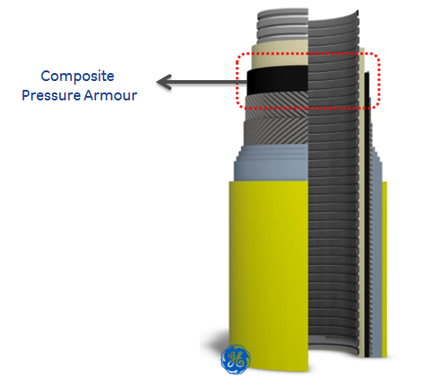
Figure 1 Composite pipe structure
The composite flexible riser offers the following advantages over a traditional structure:
- 30% lighter.
- 20% savings on total installed cost.
- Deeper water and higher pressures.
- Top end tension reduction.
- Fewer buoyancy requirements.
- Reduced number of mid-line connections due to increased reel capacity.

Problem Statement
The offshore flexible pipe market is forecast to grow 45% from 2015 to 2020. The majority of this growth is in the >1,000m water depth with a significant proportion in ultra-deep water (>2,000m) driven by the pre-salt discoveries off Brazil and in the Gulf of Mexico. The combination of ultra-deep water and relatively large pipe diameter is outside of current flexible pipe qualification scope and imposes severe engineering challenges to rigid pipe technologies. While flexible pipe will be the best solution to these needs, the aforementioned challenges will require technical innovations in current flexible pipe technology and rigorous testing to prove to customers that these new technologies are robust and durable.

Background and Existing Technologies/Methodologies
Current State of the Art: Conventional unbonded flexible pipe designs are a multi-layer construction based upon a thermoplastic pipe liner reinforced with metallic materials. A typical construction is shown in Figure 1.
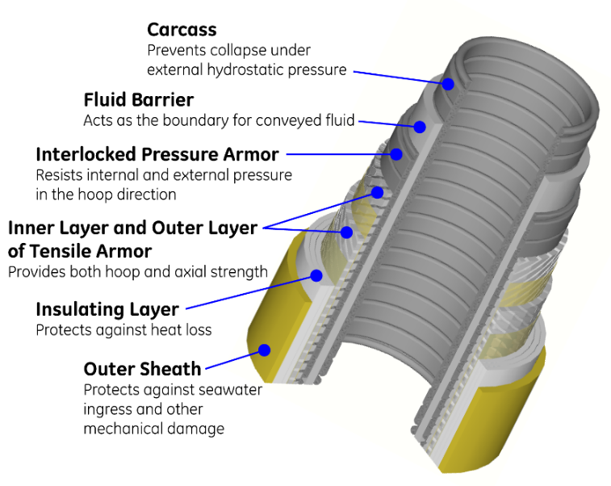
Cutaway schematic indicating the multi-layer construction of conventional un-bonded flexible pipe designs.

Each layer has a specific function as listed in Figure 1, where the metallic layers include: a carcass for collapse resistance, hoop armour for pressure resistance, and tensile armour to carry axial tension and pressure endcap loading. Unbonded flexible pipes are individually designed to the required field specification by optimizing the layer geometry and dimensions, adopting a modular approach that enables custom solutions to be delivered to operational requirements. These operational requirements also define the design space of the pipe system where the mass, endcap load and dynamic response of the pipe are used to define a stable riser or flowline configuration and installation strategy. Ideally, for cost effective installation, flexible pipe should be optimized to be stable under its own weight with the minimum of ancillary equipment such as buoyancy modules. Typically, flexible pipes are delivered in continuous lengths defined by the delivery reel size or by a carousel-equipped vessel. For deep-water applications, several lengths may be joined together if necessary. Typical reel capacity is approximately 1000m, related to the typical lifting capacity of 300 tons.

In addition to the conventional flexible pipe construction described above, one alternative technology that has been investigated recently involves the substitution of both metallic pressure and tensile armour layers with lightweight composite materials. In addition to being relatively immature, this approach suffers from several limitations:
- The use of thermoset resins unqualified for oil & gas fluid exposure in the composite layers
- The need to transition the axial load from the end fitting to the composite material
- Composite structural members are unprotected from impact damage from handling
- Construction creates an intrinsically underweight design, requiring additional weights for stability and adding complexity
The main challenges for flexible pipe design for ultra-deep water are the top tension and collapse resistance capabilities and increasing sour-service requirements.
Top tension depends upon the weight, pressure end cap load, and dynamic system movements due to vessels or sea state.
Collapse loading is due to external hydrostatic pressure for the maximum water depth. Top tension performance may be improved through the use of high specific strength axial armour. Collapse resistance may be improved by a larger formed metallic carcass section, which can also be combined with larger hoop armours and/or intermediate seal layers in the pipe.
Both of these solutions add weight to the structure that, in turn, increases the amount of top tension, reducing the self-supported length of pipe and introducing a buoyancy requirement to the system. Forming an interlocking carcass of deeper cross-section and thicker material also quickly becomes self-limiting due to the size and power of machine required to produce the section.
Corrosion resistance requirements can also affect the weight of the pipe, as sour resistant steel grades are generally softer with lower ultimate tensile strength (UTS) than sweet grades, meaning thicker sections are required to resist the equivalent loading.

Proposed Hybrid Design Approach
Flexible pipelines are used within the subsea oil and gas industry for their inherent advantages when compared to rigid pipelines. Flexible pipelines can offer advantages over rigid pipelines such as rapid deployment, ease of use and ability to be deployed into complex operating scenarios. The current flexible pipeline design comprises several functional polymer and metallic layers. Each functional layer is designed to address a specific need within the structure of the flexible pipe. These functions include fluid containment, chemical resistance and insulation as well as operational loads such as collapse resistance, internal pressure and pipeline tensile strength.
The present concept introduces high specific strength and stiffness thermoplastic composite materials into the hoop resistance functional layer, enhancing the strength to weight ratio and global structural response of the unbonded flexible pipe. The reduced self-weight of the hybrid pipe structure enables deployment in deep water with a free-hanging catenary or minimal ancillary configuration.
A summary of the advantages of the hybrid design technology approach compared with a composite-only design is as follows:
- No additional risk on end fitting technology. A hybrid design offers conventional axial load transition through the metal tensile armour. This enables us to make only minimal changes that give maximum effect with regard to the pipe functional layers
- Full thermoplastic fusing between reinforcement and liner, avoiding issues of liner collapse caused by explosive decompression.
- Use of proven materials (thermoplastic) as the matrix for the composite. Permeation can allow process fluids to access reinforcement matrix; the use of proven thermoplastics imparts superior chemical resistance.
- Design optimized for system stability without the need for ancillaries such as weights or buoyancy.
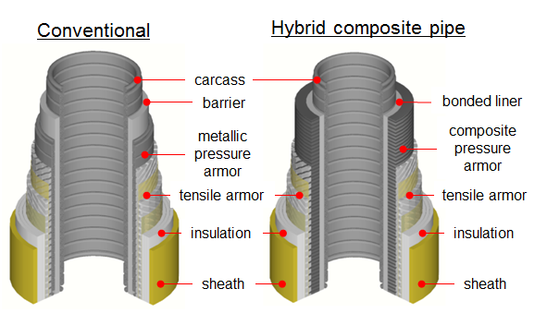
Comparison of hybrid bonded composite and conventional unbonded flexible pipe solutions – a toolbox approach

Main Functional Layers

Carcass
When the flexible pipeline is deployed subsea it is subject to high external loads. To resist these external loads we utilize a spiral wound and interlocking metallic layer known as the carcass, the innermost layer of the pipe. The carcass layer relies on the second moment of inertia and through thickness/stiffness to provide its collapse resistance.

Barrier
The barrier layer is designed to provide the seal for the internal fluid, gas or hydrocarbon. The Flexbarrier™ is a polymer layer extruded over the carcass to form a boundary for the conveyed fluid. The Flexbarrier material must be chemically resistant to the conveyed fluid and unaffected by its service conditions. Material options include PA-12 and PVDF driven by temperature and static/dynamic service. PA-11/PA-12 service life analysis is required for temperatures above 55°C. PVDF can be used up to 130°C. Traditionally dual layer PVDF is required for all dynamic services (inner sacrificial wear layer). However, GE has qualified a single layer PVDF barrier, which will be offered as preferred solution.

Composite Pressure Armor
Composite pressure armour is bonded to the barrier layer providing the required hoop resistance for the hybrid pipe structure. This layer consists of carbon fibre impregnated with a thermoplastic matrix. The thermoplastic matrix is the same basic polymer as that used in the barrier layer. This ensures chemical compatibility and the required bonding between the composite structural layer and barrier layer. The composite layer is designed as a balanced laminate, with fibre angles which vary from ±89° to ±55° and is specific to the bespoke pipe structure. The viscoelastic nature of the polymeric matrix and tensile performance of the fibre ensure optimum hoop performance levels under the effects of flexural (bend loading), temperature (Polymer dependent, see barrier), pressure, and fatigue. Advanced tape placement with focused heating and bespoke manufacturing knowledge ensures complete bonding between the composite pressure armour and barrier layer. This ensures that the rapid gas decompression and chemical compatibility of the interface is comparable to that of the polymer barrier layer. The arrangement of the inner layers of the hybrid pipe structure is illustrated in Figure 2-1.
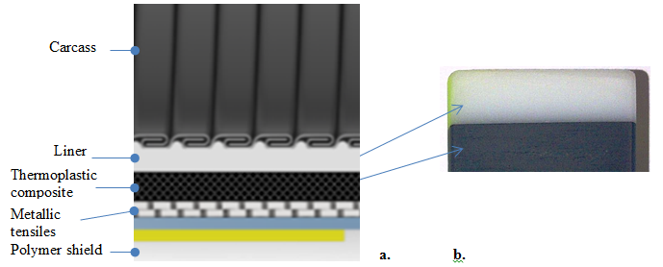
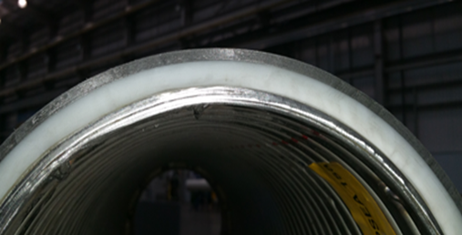
(a) Schematic cross-section of the pipe wall, (b) polished bonded liner/composite cross-section and (c) pipe wall cross-section showing carcass, liner and composite hoop layer

Metallic Tensile Armor Layer (T1 and T2)
The pipe's tensile strength is provided by two or more spiral wound metallic layers known as the Flextensile™ layers. These layers are torsionally balanced and are applied to the pipe in multiples of two depending on the overall tensile strength requirement. Within this document, this compound layer will be referred to as the 'tensile layer'. The tensile layer relies on material strength to provide individual load carrying capacity and in addition may contribute to internal pressure or hoop resistance of the flexible pipeline.

Additional Layers
Initial layers included in conventional unbonded flexible pipe design:
- Tape layer between composite pressure armour and tensile armour
- Tape layer between tensile armour layers
- Tape layer between tensile armour layer and insulation
- Insulation layer (as required)
- Outer sheath
Additional layers applied as in the conventional case include; tapes (Flexwear™, Flextape™), insulation and the outer sheath. Tape layers are used as manufacturing aids, abrasion layers (to mitigate interlayer interaction) and to provide lateral and radial (birdcaging) buckling resistance to the tensile armour layers. Insulation is applied as necessary to achieve the required thermal response of the pipe wall and the outer sheath seals the pipe annulus protecting the structural layers from external impacts and abrasion, also providing environmental resistance against UV and seawater conditions.

Summary of all layers and functions
Layer | ​ | Description | Major Function
Trade Name | Industry Term | ​ | ​
Flexbody™ | Carcass | Fully interlocked internal carcass | Provides collapse resistance
Flexbarrier (barrier) | Internal pressure sheath | Thermoplastic inner fluid barrier | Seals internal fluid
Flexliner™ (liner) | Intermediate sheath | A type of Flexbarrier used on smoothbores, which do not have a carcass | Seals fluid in smoothbore pipes
Composite pressure armour | Pressure armour* | Carbon fibre composite layer | Provides hoop strength
Flextensile (tensile wires) | Tensile armour* | Spiral-wound tensile armour. A flattened strip made from rod on classic designs; slit sheet or tensile tapes on some newer designs | Provides axial and hoop strength
Flextape |  | Polymer tape/filament tape layer | Manufacturing aid/anti-buckling
Flexwear (wear layer) | Anti-wear layer | Thermoplastic wear layer | Limits steel layer wear, constrains Flextensile wires and acts as a manufacturing aid
Flexinsul™ | Insulation layer | Thermal insulation | Decreases heat loss
Flexshield™ (shield) | Outer sheath | Thermoplastic outer sheath | Acts as environmental protection
* pressure armour and tensile armour are collectively known as 'armour wire' | ​ | ​ | ​

End Fitting - Background
The end fitting design and processes form an integral part of the pipe system and are addressed in parallel with the development of the composite layers. With the hybrid design approach being pursued as a part of this program, the conventional end fitting design for anchoring the metallic axial reinforcement remains unchanged and only minimal modifications are required to secure the composite hoop layer.
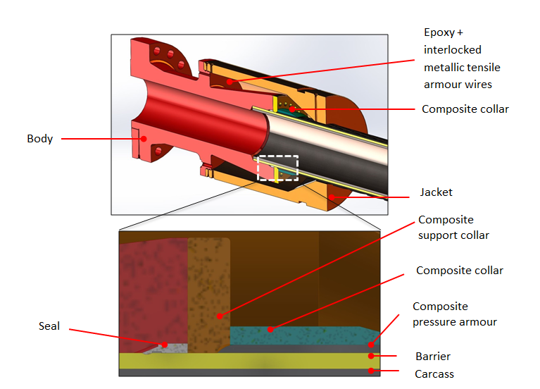
Figure 2 Composite pressure armour end fitting concept

(Not shown: metallic tensile armour layer, tape layers and tensile armour layers, outer seal, insulation and outer sheath)
A cross-sectional view of a composite pressure armour end fitting design is presented in Figure 3-1. As with conventional flexible pipe technology shown in Figure 3-2, the axially oriented tensile wires are anchored in an epoxy casting that is mechanically gripped in the wedge shaped cavity between the metallic end fitting body and jacket.
The majority of the end fitting components remain unchanged from those qualified for conventional unbonded flexible pipes.

Key Changes to Components
For reference all key components of conventional end fitting are shown in Figure 3-2. Figure 3-1 highlights all key components highlighted in present Composite pressure armour concept.

Termination of Barrier
The bonded composite layer is removed from the barrier by machining prior to termination of the barrier in the end fitting. The termination is then identical to that used in a conventional unbonded flexible pipe system.

Seal
The seal is formed using the same swaged metallic seal ring component as qualified for conventional unbonded flexible pipes. The seal is swaged between the body forging and the exposed polymer barrier to form metal/metal and metal/polymer seals.

Composite Collar
The end of the bonded composite hoop armour is reinforced using a metallic collar analogous to the Flexlok collar used in a conventional unbonded flexible pipe. The collar is redesigned to ensure a close fit to the bonded composite armour and to provide local axial fastening to the bonded composite pressure armour.

Composite Support Collar
The support collar enables separation of the composite collar, jacket and seal ring area. This ensures the composite end termination is supported in the hoop direction.
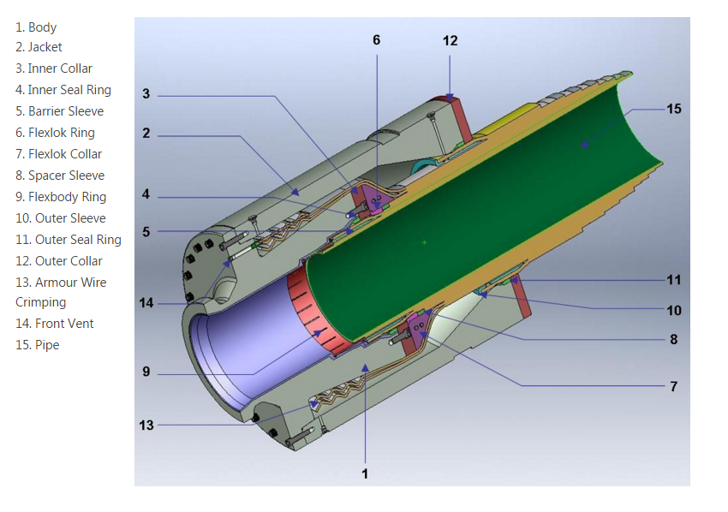
Typical end fitting schematic for conventional pipe with metallic Flexlok

Manufacturing Process
The manufacturing process for continuous production of this novel bonded thermoplastic matrix composite pipe liner involves winding unidirectional fully impregnated thermoplastic composite tapes onto an extruded liner. Compatible materials are selected that allow the reinforcement matrix to be fused to the liner to form a fully bonded structure by application of heat.
Conventionally unbonded flexible pipes are manufactured layer-by-layer using reel-to-reel operations. For the composite hybrid construction, the composite layer manufacture is a separate step performed before the metallic layer processes

Module 1 Composite Pressure Armour Production Machine
The bonded composite manufacturing line will be a modular system consisting of several identical Automated Fibre Placement (AFP) heads on a rotating platform. This equipment will be used to 'layer' and weld carbon composite tapes to form a variable thickness composite pressure armour to replace the metallic Flexlok layer found in the conventional pipe structure.
Module 1 is the first of these AFP machines and due to the modular nature of the final production machinery, can and will be used to produce a qualification product that is identical to that which will be produced on the final production line.
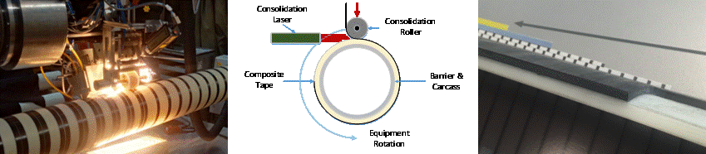

Pipe / Technology Qualification
Manufacturing qualification samples on the production line equipment is a key requirement of the industry regulations for flexible pipe and is normally a major constraint within any new product development program. Cost, time and risk will all be reduced by using the modular equipment approach for this program.
This equipment is also required to complete the final elements of the technology & product development.

Factory Qualification
There is also a requirement within this program to manufacture pipe in significant lengths. The reasons for this are twofold. The first is to prove the stability of the manufacturing process and the consistency of the product. The second is to ensure that the logistical element of manufacturing this new product has been proven before the product release.
Manufacturing trials will produce several hundred metres of pipe to ensure we can integrate into current procedures prior to making a full riser which is the final Libra qualification deliverable

Project Approach and Execution

Project Approach
GE will employ its comprehensive framework for innovation development and new product introduction to structure and execute this project.
This framework contains a phased approach and consists of several proven tools to aid innovation and product development. An entirely customer focused development process; it will enable the project participants to maintain a very strong influence during the key stages of the project.
This approach will enable us to develop several iterative prototypes during this program that will be assessed and approved by the business at key stages of the program. This will allow the efficient development of the suite of tools that we need to add our existing flexible pipe 'design toolbox' as well as to build the capability and knowledge to support further composite innovation in the future. This approach will also enable GE to maintain the focus for development on the needs of the industry and will provide regular opportunities for key players to review progress and effect the direction and objectives for the product development.
The following document will outline the program approach as well as the key tasks and development / qualification plan.

Development streams
The innovation development framework, as applied to this project has 4 distinct streams of work. These are:
Stream 1 – Pipe design and proof of concept
This includes all material development, design & analysis as well as prototyping & testing.
Stream 2 – Manufacturing Development
This includes the development of prototype tape placement equipment all the way through to specifying, building and commissioning the first final production module.
Stream 3 – Supply chain development
In parallel with the product development, we will develop several material options for use in the composite pressure armour. These material options will be qualified in line with industry standards and will form a multi-threaded supply chain in time for full production readiness.
Stream 4 – Pipe Qualification
This stream of work will begin once we are satisfied with the manufacturing and performance of the prototype pipes developed during Streams' 1 & 2. The qualification will be carried out in accordance with the applicable industry and client specifications as well as any other relevant industry qualification guidelines & standards.
Figure 4 below shows the program work streams relative to the development & qualification of the new product.
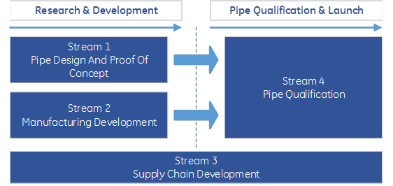
Figure 3 Project work streams

Development cycle
The work streams discussed in the last section can be thought of as key elements of the product development. When the development of each element has reached a sufficient level of advancement, we will bring these elements together to produce a viable product and measure / validate the performance. Given the timescale for development, we have the opportunity to build and test several prototypes with incremental improvements in both the manufacturing process and pipe design. This will allow us to fine tune specific capabilities of the pipe and then measure and validate these in key stages that fit with the timescale for manufacturing, materials development and material supply chain aspects of the program.
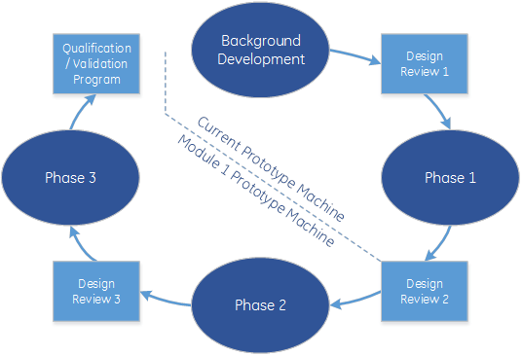
Figure 4 Project development cycle
The development cycle shown in figure 5 above, outlines the major phases within this project. In line with the GE development framework, the deliverables of each phase include physical prototypes that are tested to validate the assumptions and goals for each specific phase. Once the validation is complete, the project steering committee will take the decision to either continue as planned or make minor changes to the product & testing specification for the next phase.
This Pivot or Proceed decision will be made after a comprehensive design review which will incorporate all learning to date as well as the results of a comprehensive categorization / test program carried out for the closing phase of the project. The design review will be used to present the performance of the current prototype as well as the next stage options & expectations for the product development. This will be a customer-focused event that is designed to steer the development in the direction that best suits the needs of the end user. A formal sign off will be required and a re-assessment of the overall deliverables / scope will be made and presented as an official update to the project.
Particular to this program is the bridge between the prototype manufacturing technology and the future compact modular manufacturing line known as 'module 1'. Due to limitations in manufacturing capacity using our current prototype machine, it is necessary to construct a new machine that is better suited to the industrial application. The module 1 equipment will be procured and operational during phase 2 of the program.
Figure 6 below summarizes the project approach by bringing the work streams together with the project phases. Some key points are shown for each to demonstrate the planned evolution of the product during the program lifecycle.
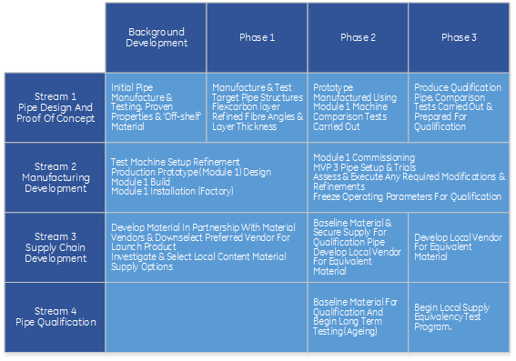
Figure 5 Project streams vs. execution phase

Project Execution
In this section we will drill down into the technical content of the program and detail the key areas of work within each stream.
A starting point for all work within this program is the pipe FMECA. A comprehensive FMECA has been carried out several times during the background phase of this technology development. The learning from this exercise has been used to structure the content of each stream of work. An additional FMECA will be carried out shortly after the project kick off to elaborate further on the issues that we need to address for our bonded liner technology as well as the other functional layers within the flexible risers. At the end of each phase within the program, a full FMECA review will be carried out, summarised and agreement sought from key clients, IVA. A summary of the FMECA will available as part of the initial program documentation for review.

FMECA
One key aspect of the program FMECA is that we are considering the interaction of all pipe layers for each key stage of the pipes life. These 'scenarios' include manufacturing, transportation, installation as well as operation. Within operation, there are also several key failure modes that we consider separately in order to select the best testing regime to verify the pipe performance. A summary of the key areas is shown below:
Components:
- Flexbody / barrier interface
- Flexbarrier
- Composite Pressure Armour (includes interface with Flexbarrier
- Composite Pressure Armour / Tensile interface
- Flextensile
- Insulation
- Sheath
- End fitting
Scenarios:
- Manufacturing
- Installation
- Operation
- Static (single) loading with fatigue & environment
- Combined loading with fatigue & environment
- Dynamic loading with fatigue & environment
- Steady State (static) – creep / stress rupture
- Dynamic – LCF / HCF
Controls:
- Design / Mfg. Controls
- In-Service Controls
- Verification / Qualification Tests
The following sections describe the project streams in more detail.

Stream 1 – Pipe Design and Proof of Concept
The prototype pipe & coupon samples within each phase will be subject to a standardised test & design review program – This will allow us to accurately measure the performance of the iterative development and enable us to plan the next stage of measurable and achievable improvements.
The only exception to this approach will be the long-term material and design validation tests. These tests will be carried out over several phases of the program. The current level of development is advanced sufficiently to allow us to justify starting these long-term tests at the earliest opportunity and will be complete within the project timeframe.
Figure 7 below shows a selection of the content that will be subject to standardised testing regimes during each phase of the program.
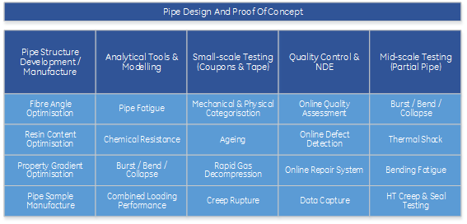
Figure 6 Stream 1 work areas

Stream 2 – Manufacturing Development
The manufacturing development stream is focussed on the production of a compact modular manufacturing line for the composite pressure armour. This development is the result of over four years of R&D by the GE Oil & Gas project team.
The composite pressure armour manufacturing line will be a modular system consisting of several identical Automated Fibre Placement (AFP) heads on a rotating platform. This equipment will be used to ‘layer’ and weld carbon composite tapes to form a variable thickness composite pressure armour to replace the metallic Flexlok layer found in the conventional pipe structure.
Module 1 is the first of these AFP machines and due to the modular nature of the final production machinery, can and will be used to produce a qualification product that is identical to that which will be produced on the final production line.
The key elements of the manufacturing development are shown below:
Pipe / Technology Qualification
- Manufacturing qualification samples on the production line equipment is a key requirement of the industry regulations for flexible pipe and is normally a major constraint within any new product development program. Cost, time and risk will all be reduced by using the modular equipment approach for this program.
- This equipment is also required to complete the final elements of the technology & product development.
Factory Qualification
- There is also a requirement within this program to manufacture pipe in significant lengths. The reasons for this are twofold. The first is to prove the stability of the manufacturing process and the consistency of the product. The second is to ensure that the logistical element of manufacturing this new product has been proven before the product release.
- Manufacturing trials will produce several hundred metres of pipe to ensure we can integrate into current procedures prior to making a full riser which is the final Libra qualification deliverable
Figure 8 below shows the complex array of sub components and systems that have been developed by GE over the course of the background research and development program.
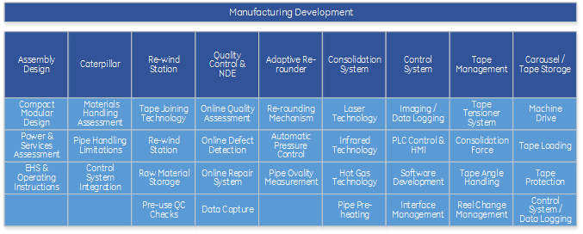
Figure 7 Stream 2 work areas

Figure 9 below shows the concept arrangement that the module 1 machine. The equipment is being developed by GE in partnership with industry experts in laser consolidation technology.
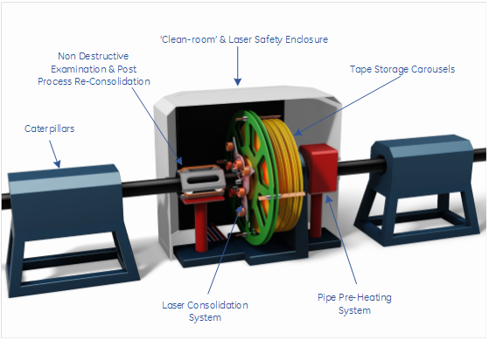
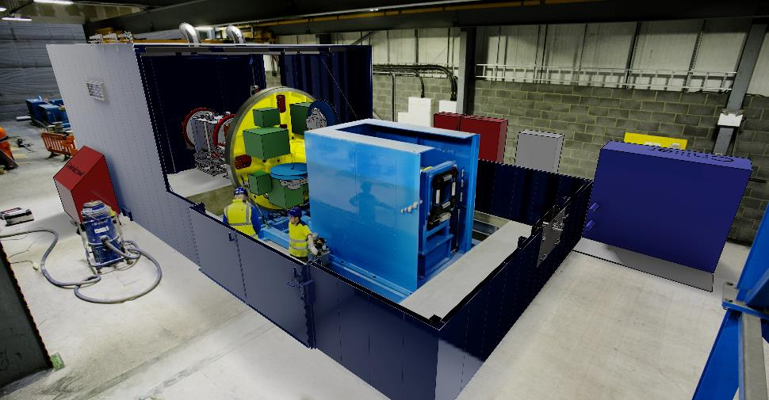
Figure 8 Module 1 manufacturing machine – GE CAPEX

Stream 3 – Supply Chain Development
The complexity of the product design vs. performance capability raised the requirement for a specific raw material specification for the carbon / polymer tapes that we use in the production of our composite pressure armour
The composite pressure armour is manufactured by consolidating multiple layers of thin composite tapes. The number of tapes required to 'build up' this layer depends upon a combination of factors:
- Pipe pressure requirement – Increased layer thickness = increased pressure resistance
- Bending radius (MBR) for storage, installation & operation - Increased layer thickness = increased MBR
- Spooling tension - Increased layer thickness = Increased stiffness & spooling tension
To meet our specific requirements, GE embarked on a wide reaching assessment of commercially available raw materials as well as a limited assessment of bespoke materials developed in partnership with our key polymer suppliers. The output of this assessment was a composite tape specification and several key partners for the development of a composite tape to meet the needs of the business.
Within this program, we will:
- Further refine the material formulation to ensure optimal performance when built into a flexible pipe layer
- Develop the supply chain to provide raw material in the quantity required for large scale pipe production, to the required product specification
- Carry out continuous improvement and new material formulation to fulfil future pipe requirements
- Integrate raw material specification and other requirements into the GE design guidelines and quality systems
Figure 10 below shows a selection of key areas that will be addressed during this work stream.
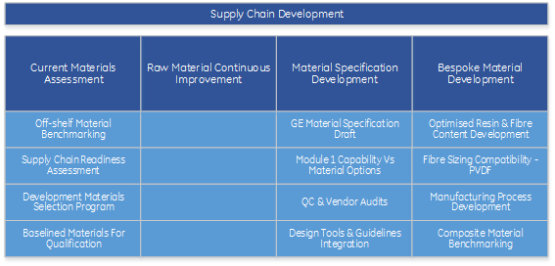
Figure 9 Stream 3 work areas

Stream 4 – Pipe Qualification and Full-scale Validation
Stream 4 addresses the qualification requirements for this new product. As with all subsea flexible pipeline qualification scopes, the pipes using composite pressure armour are subjected to a rigorous program of testing and analysis to verify that the manufactured product meets all performance and safety requirements laid down within the industry and client specifications. As this is a development program for a product that uses a new technology there are no specific recommended codes of practice in existence. For this reason, a bespoke specification will be developed in partnership with DNV and key clients.
- Qualified in accordance with client specific specifications
- Qualified in accordance with API / ISO / DNV recommended practice
- Make use of the existing qualified thermoplastic barrier qualification specification
- Full scale API pipe samples (15m +) will be used to verify pipe performance
The GE approach is to address the qualification in a series of stages. Starting at the 'small' or 'lab' scale test level, all materials will be categorised to ascertain the key performance points and then a full material qualification program will be carried out. Moving on from small-scale, a mid-scale testing program will be initiated. This mid-scale program will utilise partially manufactured pipe samples to verify the pipe performance against the analytical models generated using data from the small-scale results. Finally, once the project is at the relevant stage, GE will manufacture full-scale pipe samples with all functional layers and subject them to several full-scale verification tests.
All work within the qualification stream will be witnessed by an independent verification agent and final qualification reports will be checked and approved by DNVGL. To maintain type approval for our flexible manufacturing facility, Lloyds will be asked to review and approve the necessary work. Figure 11 below illustrates the approach GE will take for the testing and qualification of the new product.
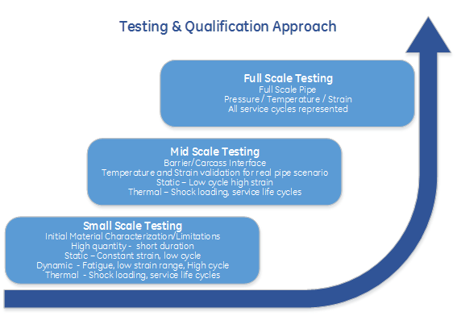
Figure 10 Testing approach

Figure 12 below shows a selection of the qualification and validation tasks that are discussed within the project statement of work.
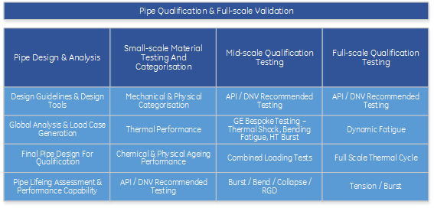
Figure 11 Stream 4 work areas
In preparation for this qualification program, GE Oil and Gas has joined several industry projects aimed at developing specifications for the qualification of composite materials in subsea environments. These programs include:
- "DNV GL Recommended Practice for Thermoplastic Composite Flexible Pipe JIP"
- "composite testing standards JIP led by Element"
- ISO standards committee in defining Thermoset, thermoplastic and composite testing standards
- "ISO 23936-4 Petroleum, petrochemical and natural gas industries — Non-metallic materials in contact with media related to oil and gas production"
- Thermoplastic Composite JIP headed by DNV
The learning from these projects will be reflected in the GE Oil & Gas specification for qualification.

Statement of work
The following section of this proposal outlines the statement of work approved for this program. This SOW includes the project management plan, consisting of a work breakdown structure and supporting narrative that addresses the key elements of the overall project. A summary of the objectives, approach, and key deliverables for each phase task is provided. The detail contained within this section is not exhaustive and a comprehensive execution plan will be provided at the commencement of each new phase.

Project Management and Administration
The following tasks are to be initiated prior to the phase 1 commencement and will be updated at the beginning of each subsequent phase. The purpose of these tasks is to provide the opportunity to agree and update the approach to the execution of the project and ensure that all current market and client requirements are considered at every stage.

Task 1: Program Management Plan & FMECA
Summary: GE will develop a detailed project management plan. The detailed plan will include an initial FMECA with participation & approval from all project partners. The plan will include project task schedules, expenditure forecast, project milestones and key decision points
Key output(s):
- Project Management Plan Draft, including project task schedules, expenditures, milestones and decision points
- Project Management Plan, including project task schedules, expenditures, milestones and decision points

Task 2: Technology Status Assessment
Summary:
Prepare technology status assessment of the state-of-the-art of ultra-deep water hybrid flexible riser technology. A critical assessment of GE offered composite technology as well as other offerings from alternative vendors will also be included in this task.
Key output(s):
- Technology Status Assessment Report

Task 3: Technology Transfer Plan
Summary:
Accelerate new technology acceptance within the subsea flexibles market through the authorship of technical papers and participation in agreed-to conferences and workshops.
Key output(s):
- Technology Transfer Plan
- Demarcation between confidential and public categorised information
- Technical papers and conference/workshop participation

Task 4: Other Reports and Special Items
Summary:
Prepare monthly reports for the program stakeholders. Each monthly report will comprise expenses and cost estimates by task, as well as succinct technical progress reports. Provide project presentations as required, and deliver a final project presentation following project completion.
Key output(s):
- Monthly reports
- Final project report

Phase 1 - Product Development
GE will execute a comprehensive development phase as part of this program. This work will build on the background research and development for the composite pressure armour that has been carried out at GE Oil & Gas since 2010.

Task 5: Pipe Structure Development & Analysis
Summary:
Pipe structures will be defined, assessed and designs will be produced for a specific range of requirements. All components and materials will be designed in accordance with GE flexibles design guidelines where applicable and any new functional layers and considerations will be produced in accordance with GE O&G R166 program recommendations.
GE will utilize analytical models of the design and available test data to estimate the initial life predictions for the conceptual design. Field global analysis & testing load case analysis will then be carried out using local field conditions for the pre-salt development.
Key output(s):
- Initial pipe designs
- Composite layer detailed design (layup angles, resin content, thickness etc.)
- End termination designs
- Global analysis
- Lifetime calculations and predictions for applicable pipe designs

Task 6: Material Development & Categorisation
Summary:
GE will test the mechanical properties, transverse stiffness, tensile strength and elongation and inter-laminar shear at elevated temperature where relevant. After the initial categorisation, there will be an exercise to down select and baseline the specific materials that will be used in the production of all subsequent samples for testing and verification purposes. Once the down select exercise is complete, further long term categorisation testing will be initiated. These will include but are not limited to:
- Ageing of the materials, assessed by exposure to water and a mixture of hydrocarbons representative of field fluids combined with residual property measurements.
- Permeation and decompression properties for SCCO2, H2S and water for each pipe design to assess the inter-laminar and bond line response.
- Materials interaction with other pipe functional layers by collation of existing data & small-scale testing.
In addition to the further categorisation testing carried out by GE, all material suppliers will be requested to carry our categorisation testing for material supply to the GE material specification. Material suppliers may also be invited to participate in the project from Phase 2. Negotiations for a material supply framework & pricing based on demand forecast will be initiated.
Key output(s):
- Material categorisation (including laminate) for initial composite material options
- Baselined materials report for all applicable pipe designs
- Material specifications & draft supply agreements for production raw materials
- Purchase of sufficient raw material to produce all required samples during phase's 1 to 3
- Composite materials qualification specification

Task 7: Prototype Pipe Production
Summary:
GE will manufacture all applicable pipes in the Newcastle flexibles factory for use in Phase's 1 to 3. All three target pipe structures will be manufactured up to the fluid barrier layer utilising the materials and design specification produced during task 5. The pipes will then be moved to the Newcastle composites facility where the composite pressure armour layer will be applied. A selection of these pipes will be dissected and used to produce all small-scale coupons for testing and categorisation during the course of the project. Further pipe functional layers will be applied to the remaining sections of pipe during the project to produce mid and full-scale pipe samples as required. A number of pipe end terminations will also be manufactured for each structure to the specification produced during task 5.

Task 8: Quality Control & NDE Development
Summary:
In order to understand fully the limitations of the composite pressure armour when applied to a flexible pipeline, all potential manufacturing defects will be investigated and reproduced using advanced testing and imaging techniques. Once mapped, the route cause and evolution of defects, including failure modes will be categorised and considered in the development, design, manufacturing, installation and operating guidelines for the composite pressure armour product. The project FMECA will also be updated and reports referenced to explain the failure mode analysis, layer usage limitations and mitigating actions.
GE will carry out the development and industrialisation of NDE techniques that can accurately categorise and repair defects within the composite pressure armour that are introduced during manufacture. The background development for these systems in isolation has already been carried out and the focus of this task will be to integrate these systems to provide an on-line automatic quality control system.
Key output(s):
- Failure mode mapping for progressive & introduced defects
- Lab-scale NDE station for composite layer defect assessment
- Consolidation quality assessment for each material combination
- On-line repair system proof of concept
- Composite layer allowable defect specification including standard operating procedures for local defect assessment & repair

Task 9: Mid-Scale Prototype Testing & Validation
Summary:
In order to test and validate the assumptions and initial designed capability of the composite pressure armour; a suite of mid-scale (partial pipe structure) tests will be carried out. The primary purpose of these tests will be to demonstrate that the product performs as expected but they will also be used as iterative prototypes that will allow us to make incremental improvements during this and subsequent project phases. The prototypes will utilise only the functional pipe layers that are applicable to the failure mode that is being tested and will be assessed in isolation before being combined into a full pipe structure for qualification and validation during later phases within the project. Alongside the pipe functional layers, the end termination modifications will also be developed and demonstrated during execution of this task.

Task 10: Design and analytical tool development
Summary:
Throughout all phases of the project, GE will develop analytical models and design tools that will allow us to carry out digital prototyping and pipe performance analysis prior to the design of any new structure within the composite pressure armour operating envelope. Although the target structures for this project are fixed, the use of these tools will be extended to cover the entire operating envelope to allow new designs to be produced for potential future operating requirements. Various elements of this work will contain GE proprietary information. Where possible, details will be released for review with program partners. During subsequent phases of the project, GE will seek IVA acceptance for these tools and they will be integrated into the existing flexible pipeline design toolbox at GE Flexibles.
Key output(s):
- Pipe fatigue methodology
- Chemical ageing model
- Pipe Burst capability model
- Pipe collapse methodology
- Pipe bending & reeling methodology
- GE proprietary design tools update for inclusion of composite pressure armour

Task 11: Phase 1 Design Review
Summary:
GE will carry out a comprehensive design review to close out phase 1 and proceed to phase 2. All reports and presentation materials shall be provided to project participants no later than 1 month prior to the scheduled review.
A Phase 2 execution plan including updated forecast for project costs will be generated as part of the phased project review process.
Key output(s):
- FMECA update
- Project stream's progress
- Product improvements for phase 2 execution
- Phase 2 detailed execution plan
- Phase 1 summary presentation

Phase 2 – Manufacturing & Prototype Assessment
Phase 2 of the project will coincide with the delivery and commissioning of the module 1 manufacturing equipment. As well as continuing the categorisation and validation of the composite pressure armour and target pipe structures, phase 2 will introduce this state of the art manufacturing technology and the program of work will assist the commissioning and optimisation and enable us to baseline all parameters and produce qualification standard prototypes in phase 3.
Standard tests and the product improvement recommendations from the previous project phase will be carried out and will enable us to narrow the focus for improvement and give us a means to assess their effectiveness.
During this phase of work, we will make use of our validated learning from the previous phase to invent and introduce new testing & qualification regimes. Additionally, any testing that does not contribute to the development and assessment of the product can be removed from the overall scope of work.

Task 12: Project Management and Administration Update
Summary:
At the commencement of Phase 2, an update exercise will be carried out for the previously defined project management and administration tasks (tasks 1 through 4). As these initial tasks will not be complete until the end of the qualification phase, the supplementary task for this phase is to capture any changes that have been discussed and approved by the project stakeholders at the close of Phase 1. This task will also present an opportunity for GE to react to current market conditions and technology advancement within the subsea flexibles space. Any additional flexible pipe innovations developed by GE can also be incorporated into the project deliverables at this stage.
Key output(s):
- Update Task 1 requirements and deliverables: Program Management Plan & FMECA
- Update Task 2 requirements and deliverables: Technology Status Assessment
- Update Task 3 requirements and deliverables: Technology Transfer
- Update Task 4 requirements and deliverables: Other Reports and Special Items

Task 13: Pipe Structure Development & Analysis
Summary:
Phase 1 pipe structures will be re-assessed and designs will be produced that incorporate any improvements and validated learning from phase 1. End termination designs will also be re-assessed in the same manner with any incremental improvements incorporated into the design. The composite pressure armour will be re-applied to the optimized pipe structures manufactured in phase 1 and these samples will be utilised in the subsequent tasks within phase 2 for testing and validation purposes.
Where applicable, analytical models, global analysis and product life predictions will also be updated with the latest properties and parameters determined during phase 1.
Key output(s):
- Updated pipe designs
- Composite layer detailed design (layup angles, resin content, thickness etc.)
- Updated end termination designs
- Updated global analysis
- Lifetime calculations and predictions
- Fatigue load cases for phase's 2 and 3

Task 14: Prototype Pipe Production – Module 1
Summary:
GE will manufacture all pipe samples for testing and verification purposes in phase 2. Within this phase of work, the composite pressure armour will be applied to pipe samples using the new 'Module 1' manufacturing equipment. This initial sample production with the Module 1 machine will be used to setup and test this equipment before refining the manufacturing properties to give the required manufacturing throughput.
A selection of these pipes will be dissected and used to produce all small-scale coupons for testing and categorisation during the course of the project. Further pipe functional layers will be applied to the remaining sections of pipe during the project to produce mid and full-scale pipe samples as required.
Key output(s):
- Module 1 delivery to NCL Facility
- Module 1 setup and commissioning
- Module 1 readiness report & standard operating procedures
- Production of composite pressure armour samples using Module 1 manufacturing equipment.

Task 15: Material Categorisation
Summary:
GE will test the mechanical properties, transverse stiffness, tensile strength and elongation and inter-laminar shear at elevated temperature where relevant. The testing, where possible, will be carried out on actual pipe structures instead of coupon samples.
Categorisation will include but is not limited to:
- Ageing of the materials, assessed by exposure to water and a mixture of hydrocarbons representative of crude oil combined with residual property measurements.
- Permeation and decompression properties for CH4 and water for each pipe design to assess the inter-laminar and bond line response.
- Materials interaction with other pipe functional layers by collation of existing data & small-scale testing.
Key output(s):
- Material categorisation as manufactured on the module 1 machine
- Updated materials report for all applicable pipe designs
- Updated material specifications & supply agreements for production raw materials
- Purchase of sufficient raw material to produce all required qualification samples
- Updated composite materials qualification specification

Task 16: Quality Control & NDE Optimisation
Summary:
Commissioning and optimisation of the NDE and repair stations that form part of the module 1 manufacturing machinery. This technology has been proven at lab scale and the purpose of this task will be to ensure that the module 1 system operates efficiently for the identified pipe structures and optimised composite lay-up. The capability of the integrated system will be benchmarked and any improvement work will be carried out during phase's 2 and 3.
Key output(s):
- Commissioning report for module 1 NDE and repair
- Gap analysis report and actions for any required improvements prior to technology qualification / approval.

Task 17: Mid-Scale Prototype Testing & Validation
Summary:
GE will carry out a selection of mid-scale pipe tests to assess the effect of any material and structure improvements identified in phase 1. This reduced testing scope will concentrate on launch client pipe structures and the results will be used to update the analytical models as well as the designed capability envelope. The prototypes will utilise only the functional pipe layers that are applicable to the failure mode that is being tested and will be assessed in isolation before being combined into a full pipe structure for qualification and validation during later phases within the project. Alongside the pipe functional layers, the end termination modifications will also be developed and demonstrated during execution of this task
Key output(s):
- Burst performance for each pipe structure
- Bend performance for each pipe structure
- Collapse performance for each pipe structure
- Bent collapse performance for each pipe structure
- Mid-scale bending fatigue assessment
- Mid-scale composite pressure armour creep assessment

Task 18: Design and analytical tool updates
Summary:
Throughout all phases of the project, GE will develop analytical models and design tools that will allow us to carry out digital prototyping and pipe performance analysis prior to the design of any new structure within the composite pressure armour operating envelope. Within phase 2 of the project, the phase 1 produced models will be optimised and additional testing will be carried out to combine the load cases and produce a comprehensive model that can predict pipe behaviour under combined loading regimes.
During phase 2, GE will seek IVA review and approval for the suite of produced analytical models.
Key output(s):
- Pipe fatigue methodology
- Chemical ageing model
- Pipe Burst capability model
- Pipe collapse methodology
- Pipe bending & reeling model
- GE proprietary design tools update for inclusion of composite pressure armour

Task 19: Phase 2 Design Review
Summary:
GE will prepare and submit a report consolidating the work conducted in Subtasks 12 through 18. The along with the phase 1 report, these results shall form the basis for the decision as to whether or not to proceed with Phase 3. A Phase 2 final review and presentation will be held.
A Phase 3 execution plan including updated forecast for project costs will be presented and agreed as part of the phased design review process.
Key output(s):
- Project stream's progress report
- Product improvement report for phase 3 execution
- Phase 2 summary report & Phase 3 detailed execution plan
- Phase 2 close out meeting & summary presentation

Phase 3 – Qualification pipe production & initial qualification assessment
The primary objective of the project phase 3 is to finalise all pre-qualification testing and analysis. This will include verification trials for all suggested optimisations and improvements from phase 2. Several long-term qualification and verification tests will also be initiated during phase 3 to allow sufficient time for these to be completed before the end of the qualification phase.
During phase 3 of the project, all materials and manufacturing parameters will be frozen in preparation for the final pipe production for qualification. These parameters will be updated within the material specification and all applicable standard operating and manufacturing procedures. Once complete the final samples for the qualification phase will be manufactured using the module 1 manufacturing equipment as well as the existing manufacturing lines at the Newcastle facility. These will then be terminated and prepared for the individual qualification tests.
At the end of phase 3, all development work will be finalised and any tasks for future development and / or continuous improvement will be reported and then transferred to the background R&D teams within GE Oil & Gas.
There will also be an additional review task at the end of this phase. The purpose of this additional task will be to finalise the business case for a full factory upgrade that will enable GE Oil & Gas to mass produce composite pressure armour for use in subsea flexibles.

Task 20: Project Management and Administration Update
Summary:
At the commencement of Phase 3, an update exercise will be carried out for the previously defined project management and administration tasks (tasks 1 through 4). As these initial tasks will not be complete until the end of the qualification phase, the supplementary task for this phase is to capture any changes that have been discussed and approved by the project steering committee at the close of Phase 2. This task will also present an opportunity for the project participants as well as GE to react to current market conditions and technology advancement within the subsea flexibles space. Any additional flexible pipe innovations developed by GE can also be incorporated into the project deliverables at this stage.
Key output(s):
- Update Task 1 requirements and deliverables: Program Management Plan & FMECA
- Update Task 2 requirements and deliverables: Technology Status Assessment
- Update Task 3 requirements and deliverables: Technology Transfer
- Update Task 4 requirements and deliverables: Other Reports and Special Items

Task 21: Pipe Structure Development & Analysis
Summary:
Final pipe designs and field analysis will be completed during phase 3. This work will incorporate any improvements and validated learning from phase 2. End termination designs will also be finalised in the same manner with any incremental improvements incorporated into the design. These designs will be used to produce the final pipe samples for qualification.
Where applicable, analytical models, global analysis, and product life predictions will be updated with the latest properties and parameters determined during phase 2.
Key output(s):
- Finalised pipe designs
- Final composite layer detailed design
- Final end termination designs
- Final global analysis
- Lifetime calculations and predictions
- Final fatigue load cases for qualification

Task 22: Qualification Pipe Production
Summary:
GE will manufacture all remaining pipe samples for qualification during phase 3. Within this phase of work, the composite pressure armour will be applied using the new 'Module 1' manufacturing equipment. This final sample production with the Module 1 machine will incorporate any required refinement of manufacturing properties and all parameters will be 'frozen' in preparation for the Newcastle factory upgrade with a full composite pressure armour production line.
Where possible, preparation for the qualification tests in the next phase will be carried out. This will include but is not limited to:
- Pipe terminations
- Test Setup
- Purchase of testing consumables
- Transport to testing facilities
Key output(s):
- Module 1 – optimisation of manufacturing parameters
- Final Module 1 readiness report & standard operating procedures (to include NDE & repair)
- Production of qualification composite pressure armour samples using Module 1 manufacturing equipment
- End fitting components manufactured
- Assembly of all mid and full scale pipe samples for qualification
- Bend Stiffeners purchase and assembly to applicable pipe samples
- Purchase of all test equipment & ancillaries (consumables)

Task 23: Material Categorisation & Specification
Summary:
This task presents a final opportunity to include any improvements to the qualification material formulation and purchase of sufficient material to enable GE to produce the final qualification samples. All reports, specifications, and supplier agreements will also be finalised during this task.
GE will test the mechanical properties, transverse stiffness, tensile strength and elongation and inter-laminar shear at elevated temperature where relevant. This testing will be limited to those materials and structures that have been further refined post phase 2.
Long-term small-scale qualification testing such as ageing and creep performance will also be initiated during this task.
Key output(s):
- Material categorisation as required
- Initiate long term material qualification testing (Ageing, creep etc.)
- Final materials report for all applicable pipe designs
- Final material specifications & supply agreements for production raw materials (for business review at phase 3 completion)
- Purchase of any improved materials required for qualification samples (to be manufactured during phase 3)
- Final composite materials qualification specification

Task 24: Mid-Scale Prototype Testing & Validation
Summary:
GE will carry out a selection of mid-scale pipe tests to assess the effect of any material and structure improvements identified in phase 2. This reduced testing scope will concentrate on the launch client pipe structure and the results will be used to update the analytical models as well as the designed capability envelope. The prototypes will utilise only the functional pipe layers that are applicable to the failure mode that is being tested and will be assessed in isolation before being combined into a full pipe structure for qualification and validation during the final phase of the project.
Key output(s):
- Burst tests as required
- Bend tests as required
- Collapse tests as required
- Bent collapse tests as required
- Mid-scale bending fatigue testing as required
- Mid-scale composite pressure armour creep assessment (optimised composite structure) as required.

Task 25: Design and analytical tool updates
Summary:
Throughout all phases of the project, GE will develop analytical models and design tools that will allow us to carry out digital prototyping and pipe performance analysis prior to the design of any new structure within the composite pressure armour operating envelope. Various elements of this work will contain GE proprietary information. Where possible, details will be released for review with clients. Within phase 3 of the project, all produced models will be optimised as required.
Key output(s):
- Optimised Pipe fatigue methodology
- Final Chemical ageing model
- Finalised Pipe Burst capability model
- Optimised Pipe collapse methodology
- Optimised Pipe bending & reeling methodology
- Finalisation of combined loading model
- Finalise GE proprietary design tools for the inclusion of composite pressure armour

Task 26: – Future Development & Continuous Improvement
Summary:
Any additional tasks identified during this and previous phases that are not specifically part of this program will be summarised and transferred to the technology organisation within Oil & Gas. These tasks will form part of the future innovation and continuous improvement strategy for this new functional technology within the flexibles product line.

Task 27: Phase 3 Design Review
Summary:
GE will prepare and submit a report consolidating the work carried out during phase 3. Along with the phase 2 report, these results shall form the basis for the decision as to whether or not to proceed with the qualification phase and a Phase 3 final review and presentation will be held.
A qualification phase execution plan including updated forecast for all remaining costs will be presented and agreed as part of the phased design review process.
Key output(s):
- Project stream's completion report
- Phase 3 summary report & qualification phase detailed execution plan
- Phase 3 close out meeting & summary presentation

Task 28: Phase 3 Business Review
Summary:
GE will conduct a review of the composite pressure armour business case. This review will finalise the capital expenditure and specification for the full composite pressure armour production line. The timing of this review is such that the estimated completion for the full production line will coincide with the completion of the qualification phase of this project.
A full specification will be released and a commercial proposal for the manufacture, installation and commissioning of the full production line will be reviewed.
Key output(s):
- Finalised business case for composite armour line integration into a flexibles manufacturing facility located in brazil
- Quotation for all work relating to the manufacture, installation and commissioning of the full composite armour line
- Go / no-go decision for initiating factory upgrade – to include budget and execution team allocation.

Qualification Phase – Full-scale pipe qualification & verification
The final phase of the project will aim to qualify the composite pressure armour as a functional pipe layer and will qualify the 'as-built' pipe structures and analytical models / methodologies. As there is no current qualification specification that covers this particular hybrid product, the specification for qualification will be developed during the previous project phases. The qualification specification will also incorporate the industry developed, specific categorisation, and testing discussed in this document.
The qualification of this product will incorporate a range of small, mid and full-scale testing as well as the verification of the various models and methodologies produced during the course of this project.

Task 29: Small-scale material categorisation for qualification
Summary:
GE will carry out a full suite of categorisation, qualification and verification testing on the combined fluid barrier / composite pressure armour applied using the module 1 manufacturing equipment. The testing program will follow the specifications produced during the development phase of this project and will be fully witnessed by our chosen IVA.
Key output(s):
- Independently verified reports for all specified elements of the small-scale testing program

Task 30: Mid-scale qualification & validation testing
Summary:
GE will carry out a full suite of categorisation, qualification and verification testing on mid-scale pipe samples with composite pressure armour applied using the module 1 manufacturing equipment. The testing program will follow the specifications produced during the development phase of this project and will be fully witnessed by our chosen IVA. Mid-scale testing will include but is not limited to the following:
- Thermal Shock
- Bending Fatigue
- High temperature burst
- Burst / Bend / Collapse (including combined loading)
Key output(s):
- Independently verified reports for all specified elements of the mid-scale testing program

Task 31: Full-scale qualification & validation testing
Summary:
GE will carry out a full suite of qualification and verification testing on full-scale pipe samples with composite pressure armour applied using the module 1 manufacturing equipment. The testing program will follow the specifications produced during the development phase of this project and will be fully witnessed by our chosen IVA. Full-scale testing may include but is not limited to:
- Full scale thermal cycle
- Burst
- Tension-Tension
- Dynamic fatigue
- This full-scale testing program will remain provisional until completion of project phase 1 FMECA.
Deliverables:
- Independently verified reports for all specified elements of the full-scale testing program

Task 32: Qualification Report & IVA Approval
Summary:
GE will qualify the composite material for use as a pressure containment layer by quantifying the minimum material properties as required by the relevant industry standards. These standards are currently in draft form but will be reflected in the product qualification specification. GE shall also demonstrate the integrity of the material / layer when used in a full-scale pipe structure. All activities will be witnessed by an independent verification agency and will be certified by the same.
Key output(s):
- Material qualification report for composite pressure armour
- IVA report and certification for composite pressure armour material
- Pipe qualification report for hybrid composite flexible pipe
- IVA report and certification for hybrid composite flexible pipe

Task 33: Approval to quote, Product Validation Review & NPI Toll Gate Reviews
Summary:
Approval to Quote (ATQ) authorizes the commercialization of an NPI. Passing ATQ authorizes Application Engineering, Marketing, and Sales organizations to begin the market introduction process and quoting of a new product. The application guidelines and restrictions for the NPI product are formally documented and approved at ATQ review.
The purpose of the Product Validation Review (PVR) is to ensure that the production representative product meets engineering design intent and product requirements based on operation field conditions and corresponding results. Additionally, this review will confirm that all aspects of the planned qualification program have been completed to a satisfactory standard and that all relevant design tools and reference material have been updated. Key requirements to confirm during this review are as follows:
- Adherence to original specification for:
  - Material testing
  - Prototype testing
  - Completion of Design Validation:
  - Design tools updated
  - Design guidelines updated
  - Risks mitigated:
  - FMECA
  - PSA, HAZOP, ASR
- Tollgate Review – Initial Production and Factory Acceptance Test. This tollgate reviews the new product design as a finished good, tests it in the factory (to the extent possible), and readies it for customer shipment. Key elements of this review are as follows:
- Decision to ship initial production unit or units
- Production release per business plan in authorized regions and countries
- Commit resources for sustaining support of follow-on production and installation/field testing
Key output(s):
- Completed ATQ (Internal GE) review & sign off
- ATQ summary report for project stakeholders
- Completed PVR (Internal GE) review & sign off
- PVR summary report for project stakeholders
- Completed Toll Gate (Internal GE) review & sign off

Task 34: Review & Close
Summary:
This task is the final step in the new product development process and serves to determine whether the developed product achieved its objectives. The following elements of the task will be completed and final presentations / reports will be produced:
- Project Summary
- Customer satisfaction and competitor reaction assessment.
- Documentation of lessons learned from marketing, product management, engineering, manufacturing, sourcing, and services; evidence that lessons learned have been feedback into the respective functions.
Key output(s):
- Project summary report & presentation
- Project technical report & presentation
- Project commercial report & presentation
- Project completion review
- Project completion report

Project Execution Plan
Project execution plan reflects the detailed work required for each phase of the composite pressure armour development and qualification program. The execution plan will be updated prior to the completion of each phase of the program.
Each work packages contains a more detailed description of individual activities and will be cross referenced with FMECA, Tasks from SOW, Results and reports.

FMECA Summary
Table 1 FMECA Summary
ID | Component | Failure | FMECA Mitigation Summary
1.1 | Carcass | - Carcass fails during manufacture at the carcass line take-up or barrier line take-up  - Carcass fails during pipe laying for the wet parking (in touchdown zone) or during reel/unreel operations on the pipe lay vessel.  - Pipe Buckling during reeling operations | Mid-scale  - Verify carcass collapse capacity of the pipe structure at mid-scale in both straight and curved configuration
1.2 | Carcass | - incorrect handling during installations due to tensioner overload or incorrect water depth usage  - Pipe cracks during operations | Small-scale  - Material Chemical compatibility test  - Tensile test (after Exposure)  Mid-scale  - collapse (after exposure to environments)  - Contact point fatigue  - Erosion Collapse and Fatigue
1.3 | Carcass | - Carcass out of spec and design  - Pipe Buckling during reeling operations  - pipe laying during wet parking. | Small-scale  - Material Chemical compatibility test  - Tensile test (after Exposure)  Mid-scale  - collapse (after exposure to environments)  - Contact point fatigue  - Erosion Collapse and Fatigue
1.4 | Carcass | - Carcass fails during manufacture at the carcass line take-up or barrier line take-up  - Crush loading during installation  - Dynamic/crush loading during operations  - Pipe cracks during operations and handling | Small-scale  - Tensile testing  Mid-scale  - Bend testing  - Collapse testing
1.5 | Carcass | - Carcass fails during manufacture at the carcass line take-up or barrier line take-up  - Non uniform loading leading failure during installation  - Non uniform loading leading failure during operation Carcass ovalised | Small-scale  - Crush / compression  Mid-scale  - Collapse testing  - Note: check if environment specific testing is required (use scaling or equivalency) compare section 1.2
2.1 | Carcass / Barrier Interface | - Effect of caterpillar and reeling on compressive loads and on carcass slippage  - Low friction causes slippage during operation  - Effect of tensioner compressive loads on carcass slippage  - Centralizing tolerance in tensioner  - Low friction causes slippage during operation  - (1) Stress leads to failure  (2) Vertical movement of the whole carcass layer and change of stress state at the anchoring point of the carcass in the end fitting | Small-scale  - Compression  - Friction factor between layers  Mid-scale  - bend fatigue  Full-scale  - Clamping force for full sample under tension, temperature and pressure cycling (number of cycles defined in Spec, i.e. 350).  - DTR test co-relation  - Dissection of samples after tests and collect evidences of nub height, wear, etc.
2.2 | Carcass / Barrier Interface | - High Extrusion in carcass gaps  - Barrier Buckling  - Bend fatigue | Small-scale  - Compression  - Friction factor between layers  Mid-scale  - bend fatigue  Full-scale  - Clamping force for full sample under tension, temperature and pressure cycling (number of cycles defined in Spec, i.e. 350).  - DTR test co-relation  - Dissection of samples after tests and collect evidences of nub height, wear, etc..
3.1 | Fluid Barrier (internal pressure sheath or liner) | - Nub size mis-control;  - Hydrostatic failure during FAT  - Poor control of extrusion / cooling process leading to whitening, crystalline phases, undesired mechanical properties  - Offshore leak test failure  - Change in field conditions (H2S + CO2, other fluids and operational conditions) leading to material's degradation, cracks within the nub area due to stress concentration and cyclic loads, swelling, RGD. Reduced Hoop loading resistance leading localized cracking Leak or Burst. | Small Scale  - Resistance to creep  - Tensile properties  - Stress relaxation properties  - Compression properties  - Hydrostatic pressure resistance  - Abrasion resistance  - Density  - Fatigue  - Notch impact test  - Coefficient of thermal conductivity  - Coefficient of thermal expansion  - Heat capacity  - Brittleness or Glass transition temperature  - Fluid permeability  - Blistering resistance  - Fluid compatibility  - Ageing tests  - Environmental stress cracking  Mid-scale  - Burst testing after exposure.
3.2 | Fluid Barrier | - Pipe operating at High pressure and temp  (over time)  - Barrier Creep (for standard product) | Small-scale  - Resistance to creep  - Tensile properties  - Stress relaxation properties  - Compression properties  - Swelling Test (Method B)  Mid-scale  - Burst creep Dependent on mid-scale testing. Use scaling or equivalency.
3.3 | Fluid Barrier | - Moisture and/or inclusion in the barrier  - Reduced Hoop loading resistance leading localized cracking | Small-scale  - Tensile fatigue  - Flexural fatigue  - Consider issuing guidelines for manufacturing.  Mid-scale  - Burst  - Bend fatigue. (This testing to be guided by results of small scale testing).
3.4 | Fluid Barrier | - Thermal Shock (Sudden changes on temperature)  - Sudden changes on temperature | Small-scale  - Fatigue  - Notch impact test  - Coefficient of thermal conductivity  - Coefficient of thermal expansion  - Brittleness or Glass transition temperature  - Environmental stress cracking  Mid-scale  - Thermal cycling test
3.5 | Fluid Barrier | - Pressure + Strain at MBR  - lower Pressure + Strain below SBR  - Pressure + Strain below OBR  - Pressure + Strain | Mid-scale  - Tensile testing to bench mark relative strengths.  Consider Mid-scale testing for Majority of samples.  Full-scale  - Pressure testing  - Bending followed by pressure testing  - Full-scale Burst followed by bend test
4.1 | Barrier / Pressure Armour Interface | - Long term storage – Reel  - Long Term Operation Stress relaxation | Small-scale  - Resistance to creep  - Tensile properties  - Stress relaxation properties  Mid-scale  - Burst  - Creep
4.2 | Barrier / Pressure Armour Interface | - Shut down/Start up or abnormal conditions (RGD conditions), resulting in leakage or burst.  - Fatigue of the interface and pressure armour or liner failure, mainly at bend stiffener and TDP pipe sections. Matrix dominated (covered in interface) | Mid-scale  - RGD (Rapid Gas Decompression)
5.1 | Composite Pressure Armour | - Bending stress rupture due to long term storage on reel or carousel. Consider the situation of the pipe laying being halted for three days under tension loads, along with the possibility of the reuse of a pipe under aged conditions.  - Pipe operating at pressure and temperature. Matrix dominated directional creep of the structural composite layer resulting in creep rupture. | Small-scale  - Creep rupture coupons in 0 and 90° directions to establish static regression lines. GE to check if 90C is enough to comply with Libra internal fluids  - Hoop and axial creep rupture on liner + laminate samples.  - Restrained creep rupture simulating interface with tensile armours.  - Bending stress rupture on carcass + liner +CPA midscale samples (no environment) Is it a TTR test under temperature?  Full-scale  - Burst Test to create a threshold for maximum overpressure  - Creep rupture survival test. 1000hrs (Safety factor high requires x2 tests) Environments TBC based on Mid-scale test
5.2 | Composite Pressure Armour | - Bending below Global threshold strain.  - Installation and allowed strain limit exceeded. Consider the situation of the pipe laying being halted for three days under tension loads, along with the possibility of the reuse of a pipe under aged conditions.  - Abnormal loading or operation below threshold limit Composite (Matrix+ fibre) Flexural failure | Small-scale  - Static bend  Mid-scale  - Static bending of pipe up to composite layers  Full-scale  - DTR
5.3 | Composite Pressure Armour | - Long term reel storage  - Long Term Operation Over strain applied. Resultant over straining on straightening in relation to long term storage | Small-scale  - Creep / stress relaxation  - Effect of temperature  - Effect of material degradation under field internal fluid conditions (operation and re-use scenarios)  Mid-scale  - Bend test (test conditions/environments for Libra)  During bend testing or DTR (after long term storage in reel for both test samples), Measure relative displacements between hoop layer and tensile layer (including EF interface)
5.4 | Composite Pressure Armour | - Voiding  - Shut down / (RGD conditions)  - Fatigue and stress corrosion failure  - Depressurisation effects from permeated fluids on Matrix and fibre-matrix interface | Small-scale  - Laminate Cut off from pre-condition pipes exposed to bend & pressure applied during manufacturing and installation  - fatigue in aged samples (supercritical CO2, Pipe Section with Liner & composite)  - RGD (including supercritical CO2)  - Test for fatigue after exposure to supercritical Co2
5.5 | Composite Pressure Armour | - Low temperature during reeling operation  - Dynamic operation (in fatigue hot spot - Top, MWA, TDP, etc.)  - Brittle Failure (crack propagation) | Small-scale  - Laminate - Cut off  - Izod impact test  - Glass transition measurement Tg  Mid-scale  - Bend fatigue
5.6 | Composite Pressure Armour | - High Strain Low cycle loading fatigue during manufacturing and reeling  - High Strain Low cycle during installation.  - Long-term wet storage (e.g. 1-year) and pipe collapse due to creep.  Consider also the situation of the pipe laying being halted for three days under tension loads, along with the possibility of the reuse of a pipe under aged conditions.  - Crack propagation  - Matrix dominated failure | Small-scale  - Tensile fatigue in fibre direction.  - Flexural fatigue on laminate samples in hoop and axial directions.  - Thermal properties evaluation ((DSC, DMTA, etc.)  - Reeling rates.  - Izod impact test to establish threshold for dynamic/low temperature conditions  Mid-scale  - Cyclic pressure applied to hoop loading rigs. (axial load through mandrel or tie rods)  - Flexural fatigue (rotating bend)  Full-scale  - DTR - bending fatigue + pressurisation.  - Axial fatigue survival test.  - Cyclic pressure fatigue survival test.
5.7 | Composite Pressure Armour | - Low Strain high cycle loading with permeated environment.  Hoop and axial directions. Fatigue Failure | Small-scale  - Tensile fatigue in fibre direction.  - Flexural fatigue on laminate samples in hoop and axial directions  - Cyclic pressure applied to hoop loading rigs. (axial load through mandrel or tie rods)  Mid-scale  - Flexural fatigue (rotating bend)  Full-scale  - DTR - bending fatigue + pressurisation.  - Axial fatigue survival test.  - Cyclic pressure fatigue survival test.
5.8 | Composite Pressure Armour | - Thermal Stress during AFP (Advanced Fibre Placement) process (residual Stress)  Note: AFP or ATL (Advanced Tape Laying) Cracking due to residual stresses | Small-scale  - Coupons or Laminate cut off from pipe samples  - Tensile  - Bend  Full-scale  - Fatigue Burst and bend fatigue DTR
5.9 | Composite Pressure Armour | - Thermal Shock (Sudden changes on temperature)  - Thermal mismatch cracking | Small-scale  - Coupons or Laminate cut off from pipe samples  - Transition temperature evaluation / Thermal properties evaluation (DSC, DMTA etc.)  Adopt for testing Libra extreme and accidental temperatures (e.g., to be confirmed, for gas injection and gas lift: - 40 C / + 85 C; for production: - 20 C / + 110 C).  - See end fitting & Rotating bend fatigue
5.10 | Composite Pressure Armour | - Inclusions / contamination / moisture  - Manufacturing defects | Small-scale  - Tensile  - Bending  - Fatigue  - Compressive  Mid-scale  - Burst  - Bend  - Collapse
5.11 | Composite Pressure Armour | - Caterpillar loads  - Bend +collapse at TDP, during wet parking (abandonment)  - Consider re termination during installation  - Bend + Collapse  - Dynamic Fatigue  - Collapse or 2 localized compressive failures | Small-scale  - Compressive static test and cyclical test at different R ratio  - DMA Representative test to simulated touch down point compression/bending  Mid-scale  - Static bend collapse  - Cyclical bend collapse  - Fatigue after installation load cases
5.12 | Composite Pressure Armour | - Pressure + Strain at MBR or lower Pressure + Strain below SBR Pressure + Strain below OBR Pressure + Strain | Small-scale  - Split d ring test to bench mark relative strength. Consider Mid-scale testing for Majority of samples.  Full-scale  - Pressure testing + Bending followed by Pressure testing full-scale Burst
5.13 | Composite Pressure Armour | - Bend Fatigue, include stress from pipe twist and axial load increase for fatigue analysis  - Matrix dominated failure  - crack propagation  - Delamination or Shear failure | Mid-scale  - Bending fatigue and Environment.  Full-scale  - DTR (Dynamic Fatigue Test), beyond the point of failure of a pre-determined agreed number of broken wires.
- End Fitting
1.1 | Carcass Termination | - Assembly related problems, such as welding issues and possible twist (induced by sealing system activation) of the carcass with loss of seal.  - Re-termination.  - Cyclic loads and transients (depressurization, Joule Thompson Effect, and pressurisation).  - Hoop pressure Leak | Full-scale  - EF test. Guidelines to be issued for correct assembly procedure
2.1 | Flexwear Termination | - Axial Strain (Swaging process)  - Axial Strain Tensile Failure | Mid-scale  - Axial strain testing at room temperature (E1) and higher/lower temperature (E6). End fitting testing is done under pressure (E7)  Full-scale  - Axial strain testing at room temperature (E1) and higher/lower temperature (E6). End fitting testing is done under pressure (E7)
3.1 | Fluid Barrier Termination | - Misalignment during Swaging - Preparation of the barrier layer out of tolerance While re-termination  - Misalignment during Swaging - Preparation of the barrier effect of exposure to fluids Leakage | Full scale  - EF test. Guidelines to be issued for correct assembly procedure
3.2 | Fluid Barrier Termination | - Stress relaxation on the barrier during EF epoxy curing  - Thermal Stress  - Thermal Shock  - Barrier unsealing Leakage | Mid-scale  - Thermal Cycle Test  - Thermal Shock Test
3.2 | Liner-seal system | - FAT1 Installation and Offshore leak test  - Re-termination of EF1.  - Normal and transient operation including pressure and temperature cycling  - Hydrate /wax remediation or periodical pigging (changes in carcass loading)  - exposures to fluids  - Cyclic tension Creep (gap spanning), Axial expansion and radial thermal expansion or movement | Small-scale  - Coefficient of thermal conductivity  - Coefficient of thermal expansion  - Brittleness or Glass transition temperature  - Compression properties  - Creep  - Stress relaxation  - Interlayer friction factor between composite and tensile armour layers  Mid-scale  - End fitting testing under effect of temperature cycling (E6), pressure (E7). (Including pressure and temperature cycling i.e. TCR and DTR EF)  - For Axial strain testing. Please refer section 2.11. Final Proof testing at large scale  Full-scale  - DTR + TCR
4.1 | Fluid Barrier Seal | - thermal stress/ shock during operation Leakage | Mid-scale  - Thermal Cycle Test  - Thermal Shock Test
4.2 | Fluid Barrier Seal | - thermal Shock  - Leakage | Mid-scale  - Thermal Cycle Test  - Thermal Shock Test
4.1 | Composite -Liner termination | - Epoxy resin partial filling the volume allowing movements of the composite collar, through the load transferred by tensile armour;  - Gap between the Flange and termination body inducing the liner creep;  - Gap between the flange and the composite end termination inducing liner creep;  Note: For more details, refer to carcass slippage item 1.1.  - Re-termination feasibility study for using on-board laying vessel  - Refer to layer slippage in section 2.1 of UNBONDED PIPE STRUCTURE for combination of effects (EF section slippage);  - Leakage of super critical Co2 in riser top flange inducing low temperature like -70 C in the flange surface and -100 at the stud blots. So temp. in the neighbourhood in EF components and pipe body need to be assessed and low temp effect on EF studied  - Creep Leak  - Relative axial movement  - Loss of contact force between pressure armour and epoxy wedge  - Reduction of friction factor and axial load transfer to tensile armour layer (thus increase in relative axial load in composite pressure armour + liner + carcass). | Small-scale  - Compression properties  - Creep  - Stress relaxation  - effect of C02 and supercritical Co2  - Effect of Low temperature  - Interlayer friction factor between composite and tensile armour layer  Mid-scale  - End fitting testing under effect of temperature (E6), pressure (E7). Including pressure and temperature cycling.  - Testing of different composite profile end termination concepts - Final Proof testing at large scale  Full-scale  - DTR + tension-tension test - Dissection to assess presence of failures or displacements of layers.
4.2 | Composite -Liner termination | - Failure during manufacturing and FAT  - Failure during OLT  - Failure under fatigue conditions, in tensile armours or CPA  - Leak / Loss of structural integrity. | Full-scale  - Tension-tension  - Pressure Test

Project Timeline & Work Breakdown Structure
The following sections detail the packages of work within the Engineering and Manufacture work breakdown structure. For each work package, there is a summary sheet and results sheet. The work packages will be used as a container for all relevant plans and reports relating to the specific activities listed.
The summary sheet is used to outline the work package requirements and also lists the sub-packages / testing along with the specific FMECA reference mandating the work. The results Sheet is used to communicate the key results within the package as well as the routing of any information from the package that is to be used elsewhere. For example, should a series of small-scale tests feed into the generation of an analytical model, the specific parameters will be listed and a link to the modelling work package will be made.
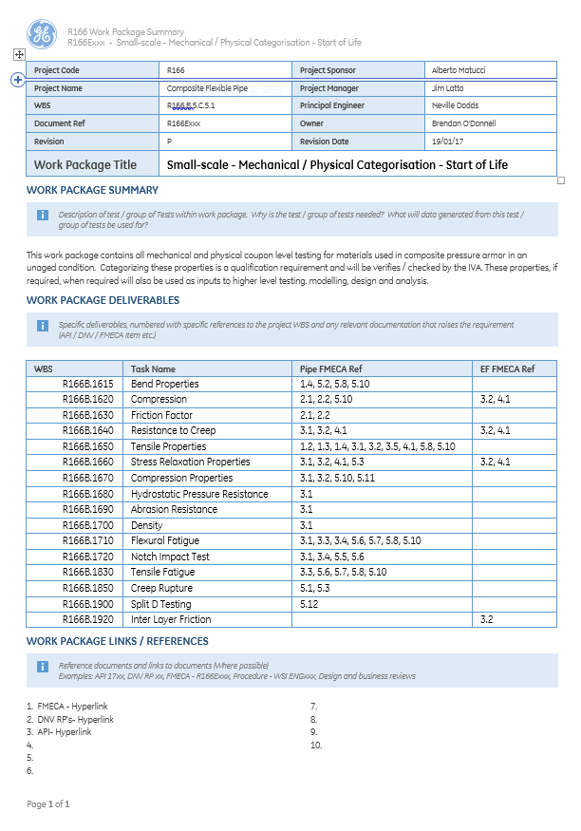
Reference to documents and links to documents (Where possible)
Examples: API 17xx, DNV RP xx, FMECA - R166Exxx, Procedure - WSI ENGxxx, Design and business reviews
Specific deliverables, numbered with specific references to the project WBS and any relevant documentation that raises the requirement (API / DNV / FMECA Item etc.)
Work package header data
Description of test / group of Tests within work package. Why is the test / group of tests needed? What will data generated from this test / group of tests be used for?
Figure 12 Work package summary sheet
A common work breakdown structure (WBS) will be used across the entire program. The figure below shows the WBS for the engineering and manufacturing work packages. This WBS will also be used as the master reference for any elements of Engineering and Manufacturing relating to product development and qualification.

R166.B.5.C Engineering

R166.B.5.C.1 Specifications

R166.B.5.C.1.1 Qualification - Pipe

R166.B.5.C.1.1.1 GE
See document(s): 3yh6n47bwa2302xyjer37n7jl7z98ara
Ge will define minimum qualification requirement for composite pressure amour pipe in various application environments. The will enable GE to follow its internal procedures and issue authority to quote for commercial department. These qualification requirements would reflect wide range of product such as flow line, jumper and riser (including Libra requirements). This specification and defined envelope should enable GE to work for projects other than Libra specification. This document would also identify gaps in qualification and related certification requirements.

R166.B.5.C.1.2 Qualification - Material

R166.B.5.C.1.2.1 GE
See document(s): la01bbwoy4loickx27tht4dohff1rykp

R166.B.5.C.1.3 Type Approval Requirements
See document(s): qiwt62qbpvzcqwto6hoky4yuwbr8eilj
GE’s current product tools, procedures and certifications are with Lloyds. Hence, composite pressure armor product will utilize both DNV and Lloyd’s certification. Also, there will areas of overlap and duplication. It is important GE works with both Lloyds and DNV to ensure we have a seamless transitions and overlaps with Type approval of composite product.

R166.B.5.C.2 Pipe Design

R166.B.5.C.2.1 Pipe Structures
See document(s): ib4mnxxda000dssuvo5yz7y1goni49y7
Pipe structures generated and considered during qualification will be client and field specific. Currently, Libra is key driver for qualification of composite pressure armor pipe. However, additional client project would be considered and respective pipe structures generated. This will enable us to either priorities and expand qualification work to suit different client requirements.

R166.B.5.C.2.2 Configuration / Global Analysis
See document(s): ib4mnxxda000dssuvo5yz7y1goni49y7
Configuration and Global analysis is closely related with performance of composite pressure armor pipe. For Libra (& other chosen project) pipe design, local analysis and fatigue analysis would be jointly optimized to give us a configuration suitable for the project. This is a closed loop design process and will require few iterative steps. This analysis will use end of life chemical &/ Physical aged properties. Also, DNV standards would be used to ensure all relevant safety factors, failure criteria and specification requirements meets the specified standards requirements.

R166.B.5.C.2.3 Transport, Storage & Installation
See document(s): cbb8j647ymlryjnegf91vwr317ifl3zy
This work package covers transport, storage and installations of composite pressure armour pipe. Transport and storage: The loading conditions during transport and storage results in application of long term, time dependent loading conditions. This includes creep, stress rupture and application of storage bend radius. Sample will be tested at small and mid-scale to evaluate the effect of these loading conditions. Physical aged samples will be tested alongside virgin samples. Installation: Composite pressure armour pipe will be installed in similar manner as conventional pipe. However, compressive strength of composite pipe structure, stiffeners and interaction with tensioner will be carefully controlled. These loading will be calculated and handling procedure will be documented. Touch point rig will also be used in conjunction with small and mid-scale sample to understand the effect of inter-layer interaction under extreme tensile/& compressive loading condition.

R166.B.5.C.3 End Fitting Design

R166.B.5.C.3.1 Conventional – Modification
See document(s): g31osvtka1psqfy8fp8mqwlcvq6gk4p4
This work package covers the design, analysis and testing to adapt and enable a standard end fitting assembly suitable for use with a hybrid composite flexible pipe. In particular this scope of work will focus on the preparation of a composite pipe prior to end fitting, the assembly and location of parts with particular focus placed on the design and swaging of a standard seal ring.

R166.B.5.C.3.2 Next Generation
See document(s): ahmsgb5rmxeht9yu0ftdzazyn1a4q7l4
This work package contains latest development GE is considering with next generation Endfitting. This will include consideration such as terminating tensile armor and seal area separately. Horizontal potting of epoxy will also be considered. GE has portfolio of patent which can be utilized to have ideal next generation endfittings.

R166.B.5.C.3.3 Bend Stiffener
See document(s): z1542dq8u9z46xf8lv3ykrcp5qhfvzf3
Composite pipe is both lighter and stiffer when compared to conventional pipe. Stiffness of bend stiffener and its length can be optimized in relation to composite pipe and interaction with composite pressure armour layer. Consideration would also be given to thermal conductivity and ability to install bend stiffener. Interaction of bend stiffener with pipe leading to End fitting on one side and free hanging length on other side will studied to check in bend stiffener design need further optimization.

R166.B.5.C.4 Design and Analytical Tools

R166.B.5.C.4.1 Chemical Interaction Models
See document(s): gill1570i8fgyf73kdr3wu69a3k7sbpw
This work package will deliver a calibrated and validated design tool based enable the calculation of permeation, swelling and mechanical property changes of thermoplastic matrix composite materials and thermoplastic polymers subjected to oilfield fluid compositions. This approach provides information which is required for input into the design of unbonded flexible pipes. The phenomena of immediate interest are permeation, polymer swelling, effect on Tg, ageing and subsequent mechanical property changes. Also, consequences of phenomenon such as rapid gas depressurization. Fluids of interest include water, CH₄, H₂S, CO₂ and hydrocarbons in mixtures typical of crude oil compositions. End of life chemically aged properties generated using this tool would be used for design purposes.

R166.B.5.C.4.2 Local Analysis Tools
See document(s): 12blugag91to849useclbprgnwg1r82m
This work package will consist of all local analysis tools not covered by ITO analysis. This will include creep, storage, materials optimization and axial compression analysis. These tools will include modifications of existing tools used for conventional pipe. It is expected for tools such as storage and axial compression the metal tensile armour wires behaviour would be similar. However, factors affecting the composite pressure armour would be analysed to check if these are self-limiting. Material optimization and Creep behaviour would specific to material combination chosen. The End of life value with conservative safety factors listed in DNV- RP-119 would be used for modelling these parameters.

R166.B.5.C.4.3 Fatigue Tool (CPA)
See document(s): 1p3i79gdh6eyoxmrrq6dpe0ad6arwbr1
This work package contains development of fatigue methodology. Fatigue of composite pressure armour will be calculated with combination sample performance at small scale and midscale. End- of -life small scale performance will be used to generate baseline understanding of fatigue properties. However, as mid-scale sample represents the true behaviour of composite pressure armour. Testing at mid-scale and failure mode would be studied in detail. Failure mode from Mid-scale (& small-scale) samples would be used alongside Laminate composite theory and/ Finite element models to develop a reliable fatigue predication tool.

R166.B.5.C.4.4 ITO Design Tools
See document(s): jxn44bpeodqkucjq05pt58y5atpibvwl
This work package contains all the design tools required by ITO team to assess the feasibility of composite pipe structure at bid/initial assessment/concept stage. Fatigue and Global analysis are not performed at this stage. This tool consists of calculations of basic structural and mechanical performance characteristic of composite pipe based on available field conditions. This tool will include calculation of burst, collapse and minimum bend radius calculation. Tool will use Laminate theory, End of life (or aged) input material properties from small scale, mid-scale and full scale testing and finite element modelling

R166.B.5.C.4.5 End Fitting
See document(s): gp7ojtahwsm5lcxs05mk1xqhsvirxsvl
This work-package will model the loading conditions in End-fitting used for composite pressure armour pipe. Current end fitting tool predicts the pressure, seal area, body and ancillary components size. These calculations would be performed for composite pressure armour end fitting after modification to material properties. As results detailed effect of radial, circumferential and axial loads and their respective loads paths would be analysed. Any resizing and changes required to end fitting components would be verified at mid-scale and modelling tool would be calibrated. Final verification will be performed at full scale. Also, effects of bend stiffener and parameters on loading conditions would be included in this tool.

R166.B.5.C.5 Small-scale Testing

R166.B.5.C.5.1 Small-scale - Mechanical / Physical Categorisation - Start of Life (API Standard)
See document(s): 628desi36ombpxs8lq4mj7mkh7ryamf8
This work package contains all mechanical and physical coupon level testing for materials used in composite pressure armour in an unaged condition. Categorizing these properties is a qualification requirement and will be verifies / checked by the IVA. These properties, if required, when required will also be used as inputs to higher level testing. modelling, design and analysis.

R166.B.5.C.5.2 Small-scale - Chemical aged - End of life (API Standard)
See document(s): yduysh2zwtbpg58hp0sg126j15813v6h
This WP contains all mechanical and physical coupon level testing for materials used in CPA in chemical aged condition. Chemical ageing will same as Libra environmental conditions and levels of chemicals reflecting the material selection. Characterizing these properties is a qualification requirement and will be verified and approved by an IVA. These properties represent the EOL chemical aged condition and will be used for testing modelling and analysis.

R166.B.5.C.5.3 Small-scale - Thermal aged - End of Life (API Standard)
See document(s): n1isi815zan9usrj8wggpldpev7nfj9l
This WP contains all mechanical and physical coupon level testing for materials used in CPA in thermally aged condition. Thermal ageing will same as Libra environmental conditions and temperature limits reflecting the material selection. Characterizing these properties is a qualification requirement and will be verified and approved by an IVA. These properties represent the EOL Thermal aged condition and will be used for testing, modelling and analysis.

R166.B.5.C.5.4 Small-scale - Physically aged - End of life (API Standard)
See document(s): tsowhdhi47owvo22lmat1vz2duidv3jo
This WP contains all mechanical and physical coupon level testing for materials used in CPA in physically aged condition. Physical ageing will same as Libra product cycle. Characterizing these properties is a qualification requirement and will be verified and approved by an IVA. These properties represent the EOL physically aged condition and will be used for testing modelling and analysis.

R166.B.5.C.5.5 Small-scale - Thermal Properties - Start of Life (API Standard)
See document(s): f0svskd1f5aadzttxj0w9zf47jh4u8ym
This work package contains all thermal properties at coupon level for materials used in composite pressure armour in an unaged condition. Categorizing these properties is a qualification requirement and will be verified / checked by the IVA. These properties, when required will also be used as inputs to higher level testing. modelling, design and analysis. The thermal properties are to be measured in both principal directions over a range of temperatures covering the pipe operational envelope.

R166.B.5.C.5.6 Small Scale - Thermal Properties - End of Life -_Aged
See document(s): if9zwf97lq2kw1zpoywnh653q5zfg2yt
This work package contains all thermal properties at coupon level for materials used in composite pressure armour in an aged condition. The aged condition referrers to chemical, thermal and physical ageing throughout the design life of the pipe. Some properties will not be required where it is deemed less conservative than the start of life properties. Categorizing these properties is a qualification requirement and will be verified / checked by the IVA. These properties, when required will also be used as inputs to higher level testing. modelling, design and analysis. The thermal properties are to be measured in both principal directions over a range of temperatures covering the pipe operational envelope.

R166.B.5.C.5.7 Small-scale - SC CO2 / H2S
See document(s): p1ur5kbr7znghr5ie7i9jvx2h2pmcw46
This work package contains all client specific testing using SC CO2 and / or H2S as either the testing medium or pre-conditioning medium. Categorizing these properties is a qualification requirement specific to Petrobras field conditions. Specific testing may be required to satisfy client requirements for other pipe designs / operators. In this case, additional testing work will be added to this work package. Limited testing (small batch) will also be required to determine any degradation of properties due to long term exposure in SC CO2 and H2S. These tests will be verified / checked by the IVA only if requested by the client. These properties, if required, when required will also be used as inputs to higher level testing. modelling, design and analysis.

R166.B.5.C.6 Mid-scale Testing

R166.B.5.C.6.1 Mid-Scale Testing & Verification - End Fitting
See document(s): xerhjggrhaslu198ffebdj3lf9t1c64o
This work package contains all end fitting mid-scale qualification and verification tests and their associated support packages (e.g. Design and build work for bespoke testing capability). The majority of the tests will be used verify modelling, design and analysis. However, tests related to qualification and verification (When mandated by DNV, API or clients) will be verified / checked by the IVA.

R166.B.5.C.6.2 Mid-scale Testing - Combined Loads
See document(s): c8lit7zdr487o3gg4a4afl4nzmkiv3b5
This work package contains all combined load mid-scale qualification and verification tests and their associated support packages (e.g. Design and build work for bespoke testing capability). Combined load refers to tests carried out on pipe samples up to the composite pressure armour where load is applied in more than one principal direction. For example, bent collapse, creep-burst and pressure-bend can be considered combined load scenarios. The majority of the tests will be used verify modelling, design and analysis. However, tests related to qualification and verification (When mandated by DNV, API or clients) will be verified / checked by the IVA.

R166.B.5.C.6.3 Mid-scale Testing - Conventional Pipe
See document(s): dw0cssvzjlzfh9ofu55f9tfoale7p304
This work package contains all mid-scale qualification and verification tests and their associated support packages carried out with conventional pipe (e.g. Design and build work for bespoke testing capability). Conventional pipe refers to pipe without any composite pressure armour. The majority of the tests will be used verify modelling, design and analysis. However, tests related to qualification and verification (When mandated by DNV, API or clients) will be verified / checked by the IVA.

R166.B.5.C.6.4 Mid-scale Testing - Single Load Scenarios
See document(s): 22xv57q6ckhvxaivxmok1yo3h4brprdh
This work package contains all single load mid-scale qualification and verification tests and their associated support packages (e.g. Design and build work for bespoke testing capability). Single load refers to tests carried out on up to the composite pressure armour where load is applied in one principal direction. For example, straight collapse, hoop burst and tension can be considered single load scenarios. The majority of the tests will be used verify modelling, design and analysis. However, tests related to qualification and verification (When mandated by DNV, API or clients) will be verified / checked by the IVA.

R166.B.5.C.6.5 Mid-Scale Testing & Verification - SC CO2 H2S
See document(s): d7jq2qageghzdl0gr8g3zx9xwj5drqnc
This work package contains all mid-scale tests and their associated support packages using SC CO2 and / or H2S as either the testing medium or pre-conditioning medium (e.g. support package is any design and build work for bespoke testing capability). The majority of the tests will be used verify modelling, design and analysis. These tests will be verified / checked by the IVA only if requested by the client. Specific testing may be required to satisfy client requirements outside of the initial scope. In this case, additional testing work will be added to this work package.

R166.B.5.C.7 Full-scale Testing

R166.B.5.C.7.1 Full-scale Testing - Dynamic Fatigue Test
See document(s): u53l93ez229tlvy7g9v7kyvi3y7893w5
This work package contains all testing to be performed at full scale in a dynamic testing rig. Dynamic testing rig refers to any full-scale rig to test a complete and terminated flexible pipe and is generally used to simulate tension, pressure, bending and temperature loading condition for actual field conditions. This test forms part of qualification testing where DTR is a minimum qualification requirement based on FMEA and/or DNV qualification requirement. DTR testing also validates small scale testing, mid- scale testing and required modelling tools/methodologies. Full scale testing will also be used where loading conditions cannot be simulated using small and mid- scale testing or where required by DNV, API or client specific qualification specifications. Several full-scale qualification / verification requirements use the lifetime approach. This approach requires that several full-scale tests are carried out using a single sample. The reason for this is to ensure that damage from multiple scenarios is considered when calculating the qualified pipe service life. Where this is the case, samples may be used across work packages and this must be taken into account when planning the sequence of execution.

R166.B.5.C.7.2 Full-scale Testing - Pipe Burst
See document(s): 9vyb4e27j8ybflepugm44ca1jg2xfay9
This work package contains full scale burst test requirement. This testing forms part of qualification testing where Burst capacity of a full pipe structure is a minimum qualification requirement based on FMEA and/or DNV qualification requirement. Burst testing also validates small scale testing, mid- scale testing and required modelling tools/methodologies. Several full-scale qualification / verification requirements use the lifetime approach. This approach requires that several full-scale tests are carried out using a single sample. The reason for this is to ensure that damage from multiple scenarios is considered when calculating the qualified pipe service life. Where this is the case, samples may be used across work packages and this must be taken into account when planning the sequence of execution.

R166.B.5.C.7.3 Full-scale Testing – Tension
See document(s): i6ycy3qvx25chkfgc5g6ngak5oocv08v
This work package contains all testing to be performed at full scale in a tension-tension rig. The tension-tension rig is used to simulate tension fatigue in a riser section for calculated field conditions. This test forms part of qualification testing where tension fatigue is a minimum qualification requirement based on FMEA and/or DNV qualification requirement. Tension fatigue testing also validates small scale testing, mid- scale testing and required modelling tools/methodologies. This work package will also assess the tension failure capacity of a full pipe structure. Several full-scale qualification / verification requirements use the lifetime approach. This approach requires that several full-scale tests are carried out using a single sample. The reason for this is to ensure that damage from multiple scenarios is considered when calculating the qualified pipe service life. Where this is the case, samples may be used across work packages and this must be taken into account when planning the sequence of execution.

R166.B.5.C.7.4 Full-scale Testing - Touch Down Point Rig
See document(s): kh62suaqko7i92p87afd7az0p18ihy6z
This work package contains all testing to be performed at full scale in a bespoke touch down point (TDP) rig. The TDP rig will be used to simulate tension, pressure, bending and temperature loading conditions with or without full scale end fittings. The TDP rig will used to address client specific requirements on touch down point loads and will also be used to test operational loading condition scenarios including installation, re-termination and combined loading. The TDP rig will also be used to condition samples to the required end of life loading cases and will enable the verification of modelling tools and methodologies Several full-scale qualification / verification requirements use the lifetime approach. This approach requires that several full-scale tests are carried out using a single sample. The reason for this is to ensure that damage from multiple scenarios is considered when calculating the qualified pipe service life. Where this is the case, samples may be used across work packages and this must be taken into account when planning the sequence of execution.

R166.B.5.C.8 Pipes and Samples
See document(s): 3a1crm5iqtkq8mypy4kosm3jyrgfizke

R166.B.5.C.9 DNV New Technology Qualification
See document(s): 4e4hnftchm0oecstu7gde6bln27nht5f

R166.B.5.D Manufacturing

R166.B.5.D.1 Module 1
See document(s): c1rt0h315wwo1r8s6wnuk9pgyjdzquzi
This package of work covers the design, manufacture, installation and commissioning of Module 1 laser tape placement system. The system will be used to manufacture a composite hoop layer for a hybrid flexible riser which can be used for qualification and testing purposes.

R166.B.5.D.2 Full Line Installation
See document(s): rnsfdxtob2gjzr2w6tj8320std89lvvr

R166.B.5.D.3 NDE & Repair
See document(s): zqy2gyj2khm0u7td6ylzq94mv4ibrggg
This package of work covers the design, manufacture, and commissioning of an NDT/repair system to work in conjunction with Module 1 laser tape placement system. The system will detect, identify and repair a small section of the composite pressure armour which falls outside the required quality assurance levels.

R166.B.5.E Quality and EHS
See document(s): xzs896nb39snl0ogsjz0lrrvz56gz27n
GE will ensure all quality and Safety procedure as laid out in DNV RP 119 and Ge’s internal procedure is followed through life cycle of product. Alongside material specification, handling and NDE work packages discussed in separate section, this work package would include whole product life cycle like transport, manufacturing, and engineering and design to ensure the product safety and quality is ensured. Also, the EHS documents generated in this work package will cover whole product life cycle.

R166.B.5.F Supply Chain & Sourcing
GE will develop a multi-source raw material supply for composite pressure armour. Currently, both PA12 and PVDF matrix composites are being considered. Additional matrix polymers will be introduced by the business over time and these will be qualified for use IAW industry standard guidelines as well as this plan. As this will be an entirely new supply chain for specific materials used to produce composite pressure armour, we are taking an iterative approach to finalising supply agreements. The evolution of those agreements as well as the secondary processes they are required for are shown in the chart below.

